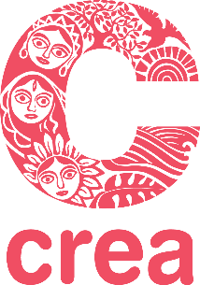

APPLICATION FORM

CREA's Feminist Leadership, Movement Building and Rights Institute
South Asia

4th – 10th December,2022
Kathmandu, Nepal

Last date for submitting completed application is, 23rd October, 2022.

Guidelines
- Attach a short version of your latest CV (not more than two pages).
- If affiliated to an organisation, please include a letter from the Head of your organisation, supporting your participation in this institute.
- If you are not affiliated to an organisation, please include a professional reference letter/letter of recommendation.
- Please type or clearly print your responses.
- All questions must be answered—your CV cannot substitute for an answer.

Full Name:
Age:
Gender:
Nationality:

 | Contact Information
Telephone:
Mobile Number: |  |  |  | Email:
 | Work Experience
Profession:
Current Position if any:
Areas of work:
Part of any forums/ Networks:
Address:
Telephone:
Email: | Website/blog:
 | Educational Background
Year | Institution |  |  |  |  | Degree

- Describe your role in the movement and/or organisation or project that you are currently involved in (not more than 150 words).

2. Write about one issue that you feel passionately about, which is related to your activism/area of work (not more than 150 words).

3. Explain why you want to take this course on feminist leadership, movement building and rights? How do you think it will contribute to you personally and in your work? (not more than 250 words)

4. How did you hear about this Institute? (not more than 50 words)

5. Are you applying for a travel grant?

6. Accommodations will be in double rooms.
Would you prefer to share with a participant of the same gender?

If there is any other information relevant to room sharing, please let us know.

Completed application forms are due on or before 23rd October, 2022. Applications received after this date will not be considered. Please send your application to
flmbari-sa@creaworld.org

