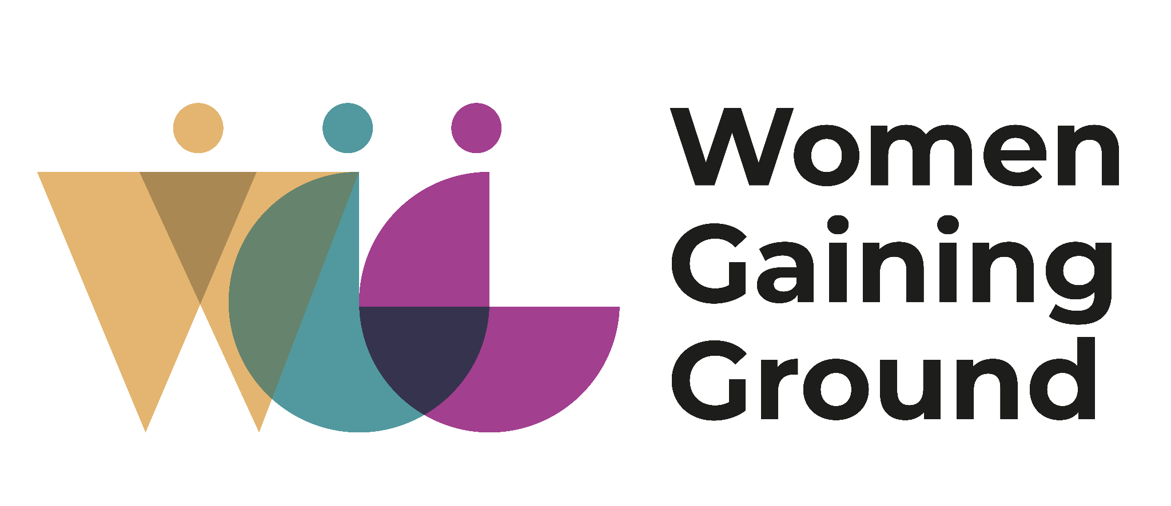

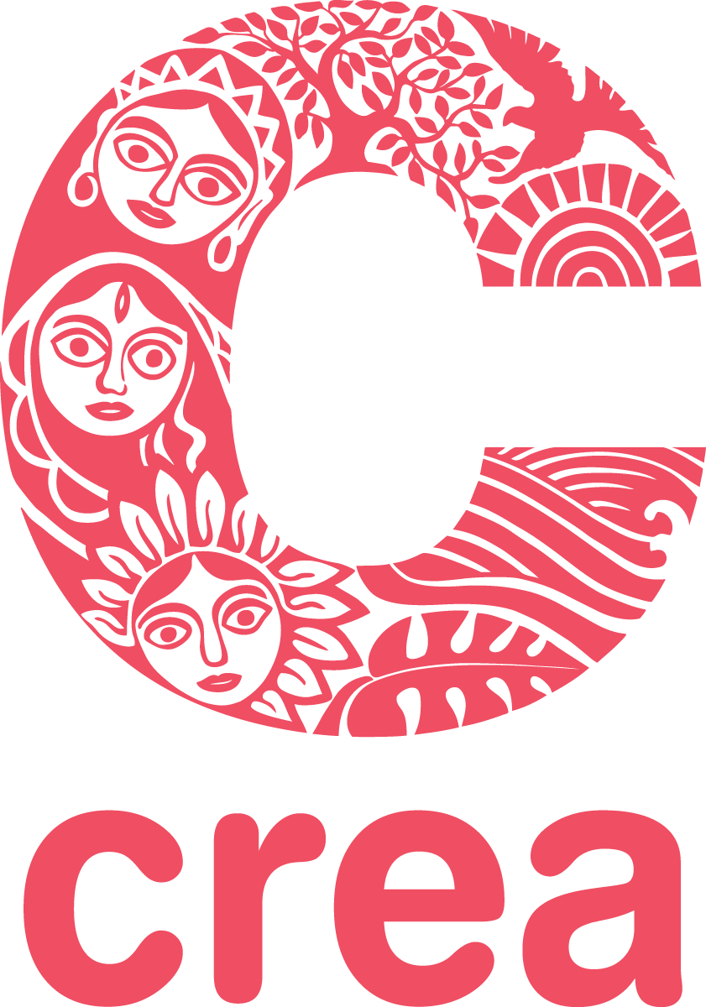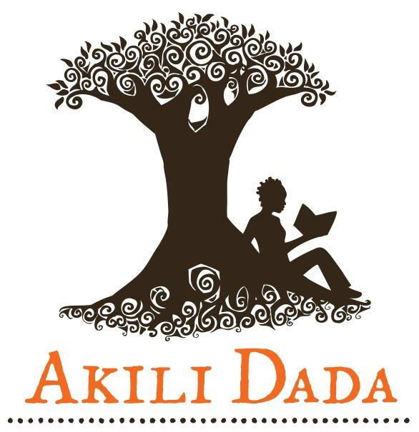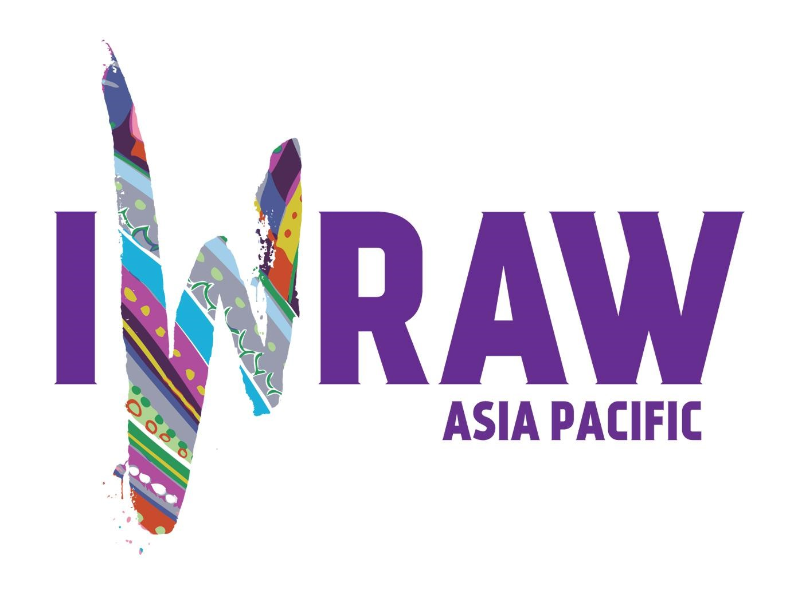

WGG 16 Days of Activism against Gender-based Violence Campaign 2022
Your Protection Doesn’t Protect Me

This year, the Women Gaining Ground Consortium, will participate in the 16 Days against GBV Campaign following a similar theme as 2021 – “Your Protection Doesn’t Protect Me”. The theme highlights the need to push back against protectionist policies, laws, and attitudes that often do more harm, in order to take action against GBV.
During the campaign, CREA and partners will share stories of resilience as shared and told by individuals and organizations, in order to truly emphasize the power of the individual and the collective when provided access to rights and decision making spaces. Stories or narratives of lived experiences and personal demands and asks have the greatest power to call attention to the need for rights over ‘protection’.

These stories (can be shared anonymously) will be shared on CREA’s and WGG partners’ social media platforms, and then compiled as a resource under the campaign theme.

Protectionist approaches do not truly protect, and can cause further harm and violence. As women and girls, persons of diverse sexualities, genders, and sex characteristics, persons with disabilities, sex workers, and many others fight back against ‘protection’ and demand for ‘rights’ instead, each individual narrative has the power to shape demands and influence policy and change.

Over the next few weeks, we ask you to share stories of resilience against GBV that speak to the theme of “Your Protection Doesn’t Protect Me”. These can be stories of,
- Championing against protectionist attitudes, laws, and policies,
- Resilience in the event of harm and violence,
- Or simply, personal reflections on the ideal feminist future you wish to see!

There is no small story of resilience. It could be the simple act of talking to someone about violence, or supporting a friend!

These stories can be in any format (from text, video, audio, art, sketches, comics, ) and can be shared with CREA via our website portal (https://creaworld.org/your-protection-doesnt-protect-2022/) or by simply emailing communications@creaworld.org. CREA will ensure accessibility when sharing the stories.

Please feel free to include your personal information (and social media handles!) or share anonymously. CREA will maintain the confidentiality of all stories shared.

These stories will be shared across CREA’s social media over the course of the campaign (25 November - 10 December 2022) and will be compiled into one resource. The resource will be a collection of lived experiences that call out for anti-protectionist approaches. We also intend to share the resource as a powerful tool of stories to guide, inspire and perhaps share bonds of resilience with others.

