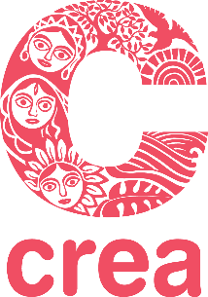

APPLICATION FORM

CREA's Feminist Leadership, Movement Building and Rights Institute East Africa
29th January – 4th February 2023
Nairobi, Kenya

The last date for submitting a completed application is 10th December 2022.

Guidelines
- Attach a short version of your latest CV (not more than two pages).
- If affiliated with an organization, please include a letter from the Head of your organization supporting your participation in the Institute.
- If you are not affiliated with an organization, please include a professional reference letter/letter of recommendation.
- Please type or print your responses.
- All questions must be answered—your CV cannot substitute for an answer.

Full Name:
Age: Gender:
Nationality:
Contact Information
Telephone:
Mobile Number: | Email:
Work Experience
Profession:
Current Position if any:
Areas of work: Part of any forums/ Networks:
Address:
Telephone:
Email: | Website/blog:
Educational Background

Year | Institution | Degree

- Describe your role in a movement and/or organization or project that you are currently involved in (not more than 150 words).

- Write about one issue you feel passionately about related to your activism/area of work (not more than 150 words).

- Explain why you want to take this course on feminist leadership, movement building, and rights. How do you think it will contribute to you personally and to your work? (Not more than 250 words)

- How did you hear about this Institute? (not more than 50 words)

- Are you applying for a travel grant?

- Accommodations will be in double rooms.
Would you prefer to share with a participant of the same gender?

Please let us know if there is any other information relevant to room sharing.

Completed application forms are due on or before 10th December 2022. Applications received after this date will not be considered. Please send your application to

flmbari-sa@creaworld.org

