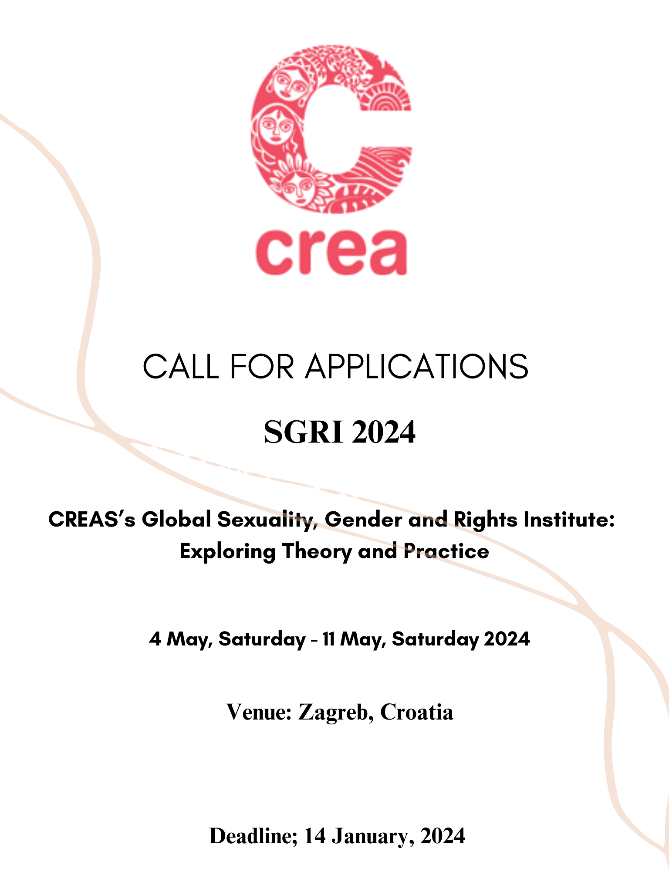

The Institute: CREA’s Sexuality, Gender and Rights Institute (SGRI) is a residential course, begun in 2007, which focuses on a conceptual study of sexuality. It examines the links between sexuality, gender and rights, and their interface with socio-cultural and legal issues. The Institute is not a training or workshop. It attempts to recast the idea
of collective and experiential ways of learning, emphasizing ‘classroom’-based
learning led by world-class faculty.

Timings: 9 am to 7 pm (on some days, past 7 pm)

Venue: Zagreb, Croatia

Arrival and departure: The Institute will be held from 4 May, Saturday to 11 May, Saturday, 2024. Participants will be expected to arrive on 3 May, Friday and depart on 12 May, Sunday and are expected to be present throughout the entire duration of 9 nights and 8 days.
Application: Applications will be accepted any time on or before 14 January, Sunday, 2024. You can apply by filling out the form here.
INSTITUTE CONTENT
Sexuality is a complex field of study, which spans multiple disciplines and areas of work. Accordingly, the course content of the SGRI will focus on a conceptual and theoretical study of sexuality, drawing from different social science disciplines and the intersections between them.
Themes:
- Social construction theories of sexuality
- Sexuality, human rights and criminal law
- Sexuality, gender and power
- Sexuality, freedom of expression and censorship
- Sexuality, media and culture
- Sexual and gender diversities, and diversity of sex characteristics and rights
- Sexuality and disability
- Anti-gender mobilization and human rights claims
- Case studies of program interventions
- Intersex rights

- INSTITUTE PEDAGOGY
Activists, practitioners and academics will teach the course using classroom instruction, group work, case studies, simulation exercises, fiction and film.
● The Institute emphasizes linking theory to practice
● Participants will learn to critically analyze policy and research their own program interventions using a rights-based approach
● The Institute is not a training or workshop, and attempts to recast the idea of collective and experiential ways of learning
● The Institute emphasizes learning led by world-class faculty

Faculty will include, in alphabetical order:
Alice Miller, JD, an Associate Professor (Adjunct) of Law at Yale Law School and Co-Director of the Global Health Justice Partnership. She is also an Assistant Clinical Professor at the Yale School of Public Health.
Carole Vance, PhD, MPH, an internationally recognized anthropologist who has published widely on sexuality, human rights, science, gender and health. She coordinated the landmark Barnard Conference on Sexuality and edited the volume Pleasure and Danger: Exploring Female Sexuality.
Estefania Vela, Executive Director of Intersecta, a feminist research and advocacy organization committed to ending gender discrimination in Mexico through the promotion of intersectional and evidence-based policies. Vela holds an LLM from Yale Law School.
Geetanjali Misra, Co-Founder and Executive Director of CREA. Misra has worked at the activist, grant-making and policy levels on issues of sexuality, reproductive health, gender and rights. She has been an Adjunct Professor at the Columbia University Mailman School of Public Health.
Ghada Boulos, a storyteller, tour-guide and intersex organizer from Nazareth. She founded Ghada’s Corner, a center dedicated to research on folklore and ethnography.
Janet Price, an activist and academic who works at the intersection of disability, sexuality and gender. She is on the Board of Disability and Deaf Arts (DaDa), Liverpool, which holds a biennial International Festival, DaDaFest.
Katrina Karkazis, PhD, a cultural anthropologist working at the intersection of science and technology studies, theories of gender and race, social studies of medicine, and bioethics, whose research and teaching examine—and challenge—scientific and medical beliefs about gender, sexuality and the body.
Meena Seshu (TBC), an activist for sex workers’ rights. She is the founder of the non-governmental organization SANGRAM (India) which is aimed at empowering sex workers.
Niluka Gunawardena, a crip-queer feminist, a disability justice and queer rights advocate, and educator. Gunawardena earned an MA in Disability and Gender from the University of Leeds, and teaches Disability Studies at the University of Kelaniya, Sri Lanka.
Sealing Cheng, who received a PhD from the Institute of Social and Cultural
Anthropology, Oxford University, and became a Rockefeller postdoctoral fellow in Gender, Sexuality, Health, and Human Rights at the Columbia University Mailman School of Public Health. She teaches at the Chinese University of Hong Kong.
A special lecture by Shohini Ghosh, a renowned essayist on sexuality and popular culture, a documentary filmmaker, and the Sajjad Zaheer Professor of media at the AJK Mass Communication Research Center, Jamia Millia Islamia University, New Delhi.
This is not an exhaustive list – faculty will include other reputable practitioners and scholars!

APPLICATION CRITERIA
The SGRI is for activists, service-providers, community organizers, researchers and human rights practitioners, working on issues of sexuality, sexual and gender diversity, and diversity of sex characteristics/ LGBTIQ rights, sexual rights, sexual and reproductive health and rights, rights of persons with disabilities, HIV/AIDS, public health, violence against women/ gender-based violence, health, and/or gender at the national, regional or global levels. A total of 30 participants will be selected to attend. Participants should be embedded in human rights and/ or feminist movements or civil society, or be working closely with them. Full-time students are not eligible.
Note: We encourage individuals from the global South to apply. We invite members of structurally excluded¹ groups to apply, regardless of location.

APPLICATION DEADLINE and SELECTION PROCESS
Applications are due on or before the c.o.b 14 Jan, 2024. Applications will be evaluated and participants will be selected on a weekly basis so you are encouraged to apply as soon as possible. To apply online, click here. If you experience difficulty with the online form, please download, fill out and email the .doc version of the form to SGRIglobal2024@creaworld.org as soon as you can. Early applications are given priority. CREA staff will review each application carefully. We will only contact applicants who have been selected to attend.
¹CREA uses the term ‘structurally excluded’ to draw attention to the ways in which societal architecture prevents certain people from enjoying the full spectrum of rights and from meaningfully and effectively participating in their communities and decision-making spaces. Our work focuses on preventing individual harms, dismantling the structures that construct and sustain those harms, and creating pathways to justice for persons excluded because of their real or perceived genders, sexualities, identities, or chosen forms of labor. At present, CREA works with structurally excluded women and girls, persons of diverse sexualities, genders and sex characteristics, persons with disabilities, and sex workers. CREA will continue to practice and advocate for broader inclusion and solidarity.

INSTITUTE COSTS
Registration fee:
● USD 250. All selected participants will have to pay this fee (including those receiving scholarships). This will have to be paid a week after you receive your acceptance letter.
Course fees:
● USD 4000: participants working with donors/ funders and international non-governmental organizations
● USD 2000: subsidized rate for all participants who work with global South organizations
Course fees include: Tuition, a resource package and accommodation (with breakfast) on a twin-sharing basis for the duration of the Institute (with check-in on 3 May and checkout on 12 May). Single room availability is very limited; participants who want single rooms should write to us at SGRIglobal2024@creaworld.org.

Course fees do not include:
● Travel costs to and from the Institute, including international airfare, visa expenses or local transport
● Daily lunches and dinners

Registration and course fees are due on or before 31 January, 2024, to be paid to
CREA.

TRAVEL, VISA and TRAVEL HEALTH INSURANCE

Participants are responsible for meeting all travel and visa costs, including travel to and from the Institute, and for obtaining a valid entry visa (if required) in time. CREA will support visa applications by providing the necessary documentation. Please check the visa requirements, as well as wait times to receive the visa, for your country to Croatia as soon as possible.

Dual- or multiple-entry Schengen visa-holders (for tourism) can enter, stay and transit in or through Croatia without an additional visa. See here for an overview of visa requirements.

Please note that every chosen participant (including scholarship recipients) will be
required to pay for and obtain travel health insurance before they travel to the Institute,
covering the entire duration of the Institute. Your travel health insurance plan should
cover COVID-19 hospitalization/ health services.

CREA will do its best to assist with visas but cannot guarantee their issuance.

SCHOLARSHIPS
A very small number of CREA scholarships are available on a need basis. Please note that the scholarship process is competitive. Apply early to be considered for a scholarship.
● Full Scholarship: CREA covers tuition, resource package, and accommodation on a twin-sharing basis
● Partial Scholarship: CREA covers USD 1250, you pay 750 to CREA
● Contribution Scholarship: CREA covers USD 750, you pay 1250 to CREA
Scholarships do not cover international travel, visa fees or local transport. Scholarship recipients will have to pay for their lunches and dinners. Scholarship recipients will also have to pay the registration fee.
Individuals eligible for scholarships:
● Those working for national/ local organizations in the global South
● Those working and residing in the global South
● Those working with or in groups to advance the rights of structurally excluded people
Individuals ineligible for scholarships:
● Those working with international non-governmental organizations
● Those working at donor agencies/ funding organizations

FUNDING OPPORTUNITIES
We encourage participants to approach donors to ask them to sponsor their participation. Possible sources for funding include the organization you work for, your organization’s donors (some funders will consider travel grants to current grantees), the Astraea Lesbian Foundation for Justice, the African Women’s Development Fund (AWDF), the Ford Foundation, the Global Fund for Women, Mama Cash, Open Society Foundations, Foundation for a Just Society, and any Women’s Funds in your region. We suggest that you begin researching options immediately upon submitting your application to us. CREA will also reach out to donors directly.

ACCESSIBILITY and LANGUAGE
We will provide reasonable accommodations for people with disabilities. The Institute will be conducted in English. English-language competency (including in reading) is strongly recommended for all applicants.
Contact: Write to SGRIglobal2024@creaworld.org if you have any questions, or if you have trouble with the online application form.

