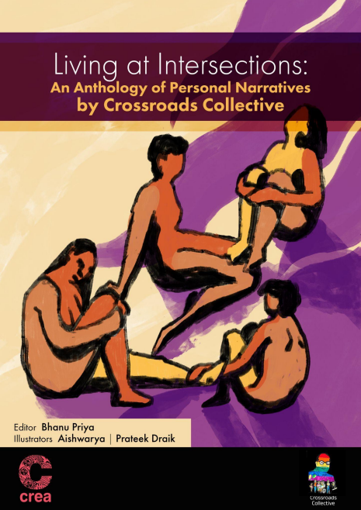
Living at Intersections: An Anthology of Personal Narratives by Crossroads Collective
Image introduction by the curator
I am Aishwarya. I am a visual artist. I live with a nervous system disorder. I was on the team for the following illustrations. I helped Prateek in conceptualizing them. So I will be describing the visuals along with the essence they were built on. Every article tells a story and every art piece holds its essence.
Cover Page Image Description (ID)
In this visual, the background is made up of two contrasting colors. Four people have been drawn sitting close to each other. Some of them have long hair and some have short hair. Two of them are sitting with their legs folded close to their chest. There is a connection between them. The first person is looking upwards and has placed their feet on the second person’s legs. The second person is facing straight ahead and has kept their hand on the third person’s folded leg. The third person is facing away and their leg is held by the fourth person. The fourth person is facing towards them and holding the third person’s leg with both hands. Each person has legs of two different colors.
Acknowledgment
This anthology is the collective work of the writers, translators, illustrators, sign language interpreters and video editors, and I wouldn’t have been able to produce this work without such a robust and dedicated team. My heartiest thanks go to the team of Create Initiative to begin with, particularly my mentors Dr Shruti Chakravarty and Gathoni Blessol. Besides them, I thank Agnieszka Krol, Smruti Behera, and other members of the Create Initiative. I thank Kuldeep Baudh for reviewing the Hindi version of the anthology and giving it the simplicity that is required in making Hindi language texts accessible to a wider audience. I thank my friend Mohammad Ali for his constant support and guidance throughout the Initiative. I thank my friends and members of the collective for believing in the project and bringing it to culmination. I finally thank my parents for being a strong support system by relieving me of some of the caregiving responsibilities I was to take up during the course of the production of this anthology.
Artists’ Introductions
Aishwarya (she/her)
Aish is a visual artist. She completed her master’s degree in visual arts from Ambedkar University, Delhi. Her work involves creating spaces using different patterns or mediums and questioning normalcy. Most of her works are in an autobiographical mode, sometimes through interactive projects. She is a fine arts student, so she works as an illustrator and curator in the field of mental health and disability.
Ankur Gedam (he/him)
Ankur is a freelance writer, content creator, and storyteller from Nagpur, with a background in banking, having worked previously at the Bank of Maharashtra. He has majored in English literature and is currently pursuing a master’s in Journalism and Mass Communication. He is a Dalit man and incorporates themes of social justice and equality in his writing. Ankur is also a vegan who is deeply passionate about animal rights and its intersection with anti-Brahmanism. Currently, he works as a freelance writer.
Anonymous (she/her)
She loves writing, but not as a daily chore. She enjoys me-time. She is also interested in cooking and painting. She hails from Guwahati, Assam. Her mother tongue is Bengali and she knows Assamese and English.
Swati Swagatika Das (she/her)
Swati is a Bahujan woman belonging to an Other Backward Caste. She started her journey of expressing herself on caste and gender through sketching. She recently presented the poetry of Basudev Sunani, a writer in the anti-caste movement in Odisha, at Delhi University, where she is pursuing a Masters in Philosophy. To explore further possibilities, Swati has started writing on public platforms. She not only acknowledges her deprivation and vulnerabilities, but also her privileges. And this, she believes, creates a space for
building solidarity across identities, across the spectrum of struggles, which is most essential in this struggle for equal opportunity.
Bhanu (she/they)
Bhanu is a non-binary, polyamorous, Shudra, queer person with psychosocial disability and chronic pain. She is a researcher in anti-caste feminist disability studies in India. She is also a writer and has written for Gaysi Family, TARSHI, Mad in Asia, The YP Foundation, and Velivada.
donna (pen name) (she/her)
donna hails from a migrated Dalit-Bengali family in Assam. She is an Ambedkarite and her engagement with the self-respect movement started after moving for higher studies. Besides reading and writing, she loves cooking and feeding friends. She also lives with PCOS, and has been a caregiver for some time now. She knows Assamese, Bengali, Hindi, and English.
Farheen (she/they)
Born and raised in Delhi, Farheen has done her postgraduation in education from Azim Premji University. She has experience at Play for Peace as a mentor. She was a chief mentor in Rahmani 30 for CA and medical students. She was part of Project Mukti as an admin and accountant. They were also a trainer in labor education and development society. Presently, she works as a cluster lead at Swataleem Foundation.
Kamna (she/her)
Kamna is an academic, educator, and artist. Currently, she is pursuing her PhD at Delhi University, where she is conducting research on caste, cosmopolitanism, and education systems in India. Before this, Kamna received her MPhil in English Literature from the University of Delhi, where she studied the changing discourses of power, identity, and experience in Dalit women’s autobiographies across various periods. Moreover, she has two years of experience as a teacher at the University of Delhi, which has helped her to develop her pedagogical skills.
Kamna is also a freelance model who has worked with several renowned fashion photographers, designers, and homegrown brands. Her passion for storytelling is reflected in her interest in how stories are conveyed through different mediums, including bodies, writings, and cameras. She is particularly fascinated by how these mediums can be used to challenge existing power structures and create new narratives that empower marginalized voices.
Dr Kurukhetra Dip (he/him)
Dr Kurukhetra Dip currently teaches Sociology at Kalahandi University, New Delhi. His PhD topic was “Representation of Disability in Hindi Cinema”. His areas of interest are disability studies, policy studies, media and film studies, and the history of social movements.
Nay (They/ Them)
Nay is a trans non-binary, mostly lesbian person. They are a Bahujan with visual impairments as well as neurodivergence. They are passionate about Diversity, Equity, Inclusion, and Accessibility (DEI&A). They are also a freelance writer, editor, and researcher. They are constantly learning about the intersectionality of their identities. They love watching YouTube video essays and documentaries during their leisure time.
Prateek (he/them)
Prateek is a dalit queer artist and urban designer with anxiety disorder. They have been researching on the emerging urbanism in the Himalayas, and worked on inclusive street design in Indian cities. They freelance at the intersection of art and the urban — creating art for activism, visibility, and joy.
Ram Singh (he/him)
Ram is a dedicated activist, programmer, and accessibility tester who has devoted his life to improving the lives of marginalized communities in India as a person with disability. He is currently pursuing his PhD at Jawaharlal Nehru University, and has a Master's degree in
Political and International Studies from the School of International Studies. He has served as a BAPSA (Birsa Ambedkar Phule Students’ Association) Central Committee member from 2018 to 2023, and as the BAPSA vice-president from March 2023 onwards. He has worked with the Accessible India campaign (launched by the government of India) at the Ministry of Human Resource Development in 2016–17 and served as an accessibility tester and programmer at the ERNET (Education and Research Network) department in 2017– 18. Ram has also been actively involved in student organizations, serving as Joint Secretary, Vice-President, and President in Ankur Society (working for persons with disability to promote their artistic growth) at Hindu College between 2015 and 2018. Ram’s achievements include being featured in the BBC documentary “Being Blind in Delhi”. In 2022, he modeled for Rishab Dahiya’s calendar Oddity - “breaking beauty stereotypes” as a disabled person.
Rani (they/them)
Rani is a Fat Neurodivergent Disabled & Chronically Ill Non binary Queer person. They have done Masters in Gender Studies from Ambedkar University, Delhi. They did their dissertation on Autoethnography of a Fat Non Binary person and their lived realities. Currently, they are an intern trainee at TARA Foundation and are a Gender Bender fellow. They have published their article on “Brahmin Men’s Privileges” on Velivada.
Runa Biswas (she/her)
Runa completed her Masters in Assamese literature from Bodoland University in Assam. She likes writing on social issues, local history, everyday experiences, and film reviews. She loves sewing and embroidering. She also assisted in photography in an article published by Feminism in India, and is now connected with Crossroads Collective. Her mother tongue is Bengali, and she knows Assamese and Hindi. She is also learning English.
Sanchayita (they/she)
Sanchayita is a non-binary person belonging to the tea tribal group of Assam. They have previously worked as an assistant editor at Asomiya Pratidin and are currently employed
in the corporate sector. Her interests include researching the history of ethnic minorities in Assam and spending time with their cats.
Sanjana H. (she/her)
Sanjana is a research scholar in the department of Sociology at North-Eastern Hill University (NEHU) in Meghalaya, working at the intersections of caste, gender, and education. She is an Ambedkarite Bahujan woman, hails from Assam, and speaks Assamese and English. Besides fighting writer’s block and structural misogyny, she likes to juggle her time between cooking and napping with her dog.
Srishti (she/her)
Srishti is a final-year student at the Faculty of Law, University of Delhi. She has completed her graduation in commerce. She is a freelance content writer and has keen interest in criminal law and legal drafting. Besides these, she has developed an interest in intellectual property rights law and taxation laws. She loves to read novels and watch K-drama.
Surya (he/they)
Surya is a queer person and has a history of living with depression and anxiety. They are an educator, currently based in Bengaluru.
CONTENTS
1. The Birth of Crossroads Collective: An Introduction to the Anthology 2. “Identity Crisis of a Teenager” by Aishwarya
3. “A Rigged Game” by Ankur Gedam
4. “Title. No Title.” by Anonymous
5. “The Chains Must Break! The Stories Must Change!” by Swati Swagatika Das 6. “Living multiple Identities” by Bhanu
7. “Owe Forgiveness to our Childhood” by Donna (pen name)
8. “That’s Me, It’s Me” by Dr. Kurukhetra Dip
9. “My Journey towards Education as a Disabled Muslim Woman in Delhi” by Farheen Anwar
10. “Changing Masks: Living with Imposter Syndrome” by Kamna
11. “My Journey of Unmasking: Caste, Gender, Sexuality, and Disability” by Nay 12. “Disability is not a problem, it is a situation: An Illustration of the Socialization of Disability” by Ram Singh
13. “A Belly Story” by Rani
14. “Whose Problem is This?” by Runa Biswas
15. “I Am” by Sanchayita
16. “An Ode to Aaita” by Sanjana H.
17. “My Journey Towards Higher Education” by Srishti
18. “Queerness, Love, Intimacy and Mental Health” by Surya (pseudonym)
The Birth of Crossroads Collective: An Introduction to the Anthology
The formation of the collective began a year ago with a few Dalit-Bahujan people with disabilities and chronic conditions coming together in a group to learn about disability
rights. We had a couple of training sessions amongst ourselves—taking turns as facilitators—on the history of the disability movement and the mental health movement. We knew since the beginning that we wanted to come together as a cross-disability group, including people with physical disabilities, psychosocial disabilities, chronic conditions, and caregivers. We could have included other disabilities as well if the group members were more diverse and we had the training to work for their inclusion.
The group definitely was not in the form of a collective then. We named it the ‘DBA disability rights group’ for our Dalit-Bahujan-Adivasi identities. However, our group was already diverse, with people coming from different intersections. We knew that we were not only working on disability but also caste, queerness, and women’s issues. We also knew that without any external backing, we wouldn’t be able to survive for long. Gradually, we faced a paucity of resource persons to train us, and we didn’t seem to have a collective vision.
The group went silent for a while until I came across a few funding opportunities for independent groups like ours. I knew that if we got one, we would be able to revive the group and have funds for its expansion, resources, and visibility. We knew that we were one of the first groups in India started exclusively by and for Dalit-Bahujan people for disability and intersectional rights, particularly disability rights. I applied for those opportunities and spoke to other members about them. After I was selected as a Creator for the Create Initiative , I decided that we should work as a collective and expand our group first. We knew that we wanted to work on disability and intersectional rights, and this was enough to get people on board. The agenda was capacity building to start with, so that we could be in a position to advocate for the rights of DBA people with disabilities or chronic conditions, and their caregivers. The name Crossroads had been in my mind for a very long time, as I wanted to start something that was essentially intersectional from the formation stage itself. Crossroads implies being positioned at the intersection of different pathways. Following discussions with the members of the collective, we decided to conduct the training sessions that would equip us to discuss not only disability but also intersectional rights. The two areas of training, i.e., the histories of the movement and an introduction to
legal rights, became our anchors in familiarizing us with the movement and prepare us to advocate in matters of policy making.
The narrative writing aspect of the project emerged with the Create Initiative application process where I realized that Dalit-Bahujan-Adivasi disabled persons were so few in number in social movements that our voices and experiences were nearly invisible. How our different social locations mark our experiences differently has not reached out and needs to be visiblized. Therefore, I first decided to document it in the form of a documentary or anthology, but later decided that an anthology would allow more creative freedom for group members to express and narrate their experiences in the ways they chose to. It also turned out to be more financially feasible, given the limited budget defined by the initiative. The documentary medium ends up being controlled and directed by the filmmaker, so much of the narrative gets shaped through the filmmaker’s lens. Independent and minimally edited narratives would allow more space to the narrators to lead the narratives and, in turn, the work of the collective.
The narrative writing process
The narrative writing process began with an additional series of online sessions facilitated by the members of the collective themselves. The sessions were planned keeping in mind the fact that our writers are new to the art of narrative writing and are still at the learning stage of how to produce a narrative. We decided to not invite external speakers for this and instead encouraged existing writers to present their personal narratives and explain the process of producing their narratives. These sessions were conducted especially to help the members understand how one expresses difficult experiences like imposter syndrome, trauma, life with a disability, how to live with pain and suffering, the struggle to write in academia, etc. We also invited an external speaker, Prof. Vijeta Kumar, to facilitate a session on how to write a narrative.
These sessions lasted for about two months, after which I identified four group members who could work as mentors to the writers. These mentors were identified on the basis of their previous experience of writing and their understanding of a narrative. Each writer was asked to choose a mentor for themselves. The mentors were themselves writers, so they became mentors to each other too, depending on each one’s preferences. The mentors
worked with the writers for two months to help them each produce a narrative. The mentorship work involved discussion with the respective writers on which theme they wanted to write on. Disability or mental health and intersectionality were two common themes given for everyone.
We understand that the narratives are presented in what may seem a raw form, because they come straight from the heart of the writers. Minimal editing has been done to the narratives with a particular critical lens towards the use of language. We have used footnotes to explain why certain potentially problematic words are used by the writers and in what context, with a regard for everybody’s sentiments. However, the fact remains that most of us are new to the art of writing itself. We welcome criticism, if it comes with the intention to help us learn how better to express our difficult experiences and raw emotions. However, any attempt to dismiss the narratives will not be entertained by the collective.
Warmly,
Bhanu Priya
Founder of Crossroads Collective
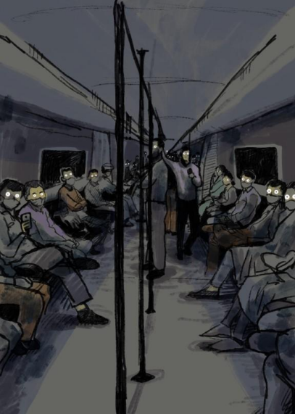
ID: This is a portrait-oriented visual. It has dim and dark colors. The visual is of the inside of a metro rail coach. The viewer’s perspective is that of standing in the middle of the coach, from where you can see both the right- and left-side seats, filled with people sitting.
A few people are also standing in the middle. The people are sitting with a normal demeanor, but they have shining, piercing eyes. From the viewer’s perspective, every passenger is looking at them and a couple are taking out phones to click their picture. The windows of the metro are extremely dark and there is very little light inside too, but the eyes are shining brightly.
Identity crises of a teenager
Aishwarya
Growing up with a disability and people’s responses to it
While growing up with a disability, I did not know I was sick. I thought every kid had to go to the All India Institute of Medical Sciences (AIIMS, in Delhi) for regular check-ups every six months. I was not informed or educated as a kid that there is an evident difference between a healthy and an unhealthy body. Since my family was strict, I just followed my parents around for all the medical tests. I remember my mom saying before entering AIIMS, “Seedha paer pehle rakhna, fir saare results thik aaenge. (Put your right leg ahead first, then all the results will be fine.)”¹
I remember looking at the doctor who was doing my echo, getting sweaty and flustered while seeing the images popping on the ultrasound machine. There were usually two reactions I got in such health examination rooms—either it was the doctor getting scared or a senior doctor calling his students to come and look at me. I vaguely remember that doctors used to ask their students in front of me what problem I had. I would look at those juniors and know that they don’t want to respond to his question. It was embarrassing for all of us there while they were looking at me like I was an alien. I thought the doctors were heartless. At the same time, I remember a junior female doctor trying to find me after tests to apologize for how his senior asked questions there in the room while objectifying me.
I also want to mention here at the same time what my parents were looking at when I was in a room to get my tests done, and a bunch of different doctors were rushing into the same room.
¹ This line is a Brahminical belief, which I was not aware about as a child. I don’t engage in any of these practices any more as an adult.
I was in the ninth standard and I did not complete my homework. I was not a bad kid. I was a kid stricken with very low immunity, and I never knew what to tell my teachers as to why I did not complete my homework. So I was punished -- made to sit cross-legged on the floor and complete my homework. Since I had black leather shoes on, I couldn’t sit like that. And my teacher got angry and hit me. Around the same time, I was also falling behind in physical training. I got home and told my mother about this. My father wrote a letter the next day which had “CONFIDENTIAL” written on it, and I was supposed to hand it over to the teacher without opening it. Which I did. Exactly. I remember no one else touched me after that in a safe way. But a few days later I found a rough copy of the letter my father had written in his diary and I googled the name of the disorder written on it. This might be the first thing I ever googled: “MARFAN SYNDROME”. That's how I got to know that I was permanently sick.
I felt discriminated against by my relatives because I was a girl and that too a sick one. I remember Daadi (my paternal grandmother) saying, “Khud toh dawai kha kar jeeti hai aur apne bhai ko bhi nahii jeene deti (She herself lives on medication and doesn’t let her brother live too).”²
I grew up with more complications as a cis-girl — flat-chested, in boys’ shoes, extremely tall by Indian standards. Other kids used to even get scared while walking near me. Not with me. Near me. They said people turn and stop to look at my height. I had no friends to back me up until I was in the eleventh standard. Mother and father were trying to make it in this new normal, a “general caste” society. And their first kid was chronically disabled. No such help was offered at school, since they were not aware of my conditions. My parents thought this was the only way to cope. I went to school even with a 103-degree body temperature.³ I thought I was not studying well and that’s why I got a high fever. I felt scared of telling my parents.
I felt that I was restricted in many ways: don’t do this, don’t run, don’t jump. And I remember my parents looking hopeless after talking to doctors. Various doctors, vaidyas (practitioners of ayurvedic medicine), clinics. I wish someone had given them the support
² This line is stigmatizing the disabled, therefore it is disabling.
³ I understand now that this is ableist.
or incentives or therapy to know that I too could have a ‘normal’ life. They were worried all the time. My father was aimless, trying to find a person who he could look up to just so he knew how to get ahead in his life to make things better for me. I say this now because I have seen old dingy research papers on my illness or my janampatri (horoscope) or astrological forecast. I could see that he was trying to find hope everywhere, even if it be “isko chandi ki angoothi pehna do (make her wear a silver ring).⁴,⁵ I know for a fact that he is an introvert, he lost his own father, mother, and brother. Now when I say I am his chronically disabled kid, I am referring to the complications of his life. I am a proud daughter and now that I can speak and tend to my own needs, he feels better every day.
I felt discriminated against while buying jeans or shoes. The shopkeepers just endlessly commented on my height and my flat feet. They really scared the hell out of me. I still never go bowling with any of my friends because you have to take off your shoes. I stopped going out. I absurdly felt comfortable at school because we had to wear the school uniform and mandatory shoes. I felt comfortable hiding under publicly followed rules. If we all are supposed to be white in color and of an ‘adequate’ height, who is going to point a finger at you? To this very day, in 2022, I cannot find jeans of my length, but it’s okay. But the judgement that comes from the salesperson is not. However, I COULD NOT FIND CLOTHES. And I did not HAVE CHOICES. I wore men’s jeans, which were bodily and socially discomforting, and my school uniform was customized, thanks to my mum. She still makes my clothes.
Dating with a disability
Eventually I tried to gain the trust of people by making jokes and being a funny person. I did not share my secrets with anyone, because no one wants to be around you when you are vulnerable.
Vulnerable = disabled + woman + Untouchable
⁴ It is believed in Hindu astrology that when a person wears a silver ring, they are always protected by the Moon’s healing powers.
⁵ I understand that this line is casteist because only upper castes had access to expensive jewelry in the past. I no longer engage in such practices.
I got into a relationship. I had to come out with both of my issues. It felt belittling. I felt that I was less than everyone else and somehow this guy was the bigger person here for ‘lowering his standards’ for being with me. This is what my society made me feel. My relationship was more like best friends forever. He treated me just the way he would treat his own blood. My family treated him like their own blood. He was scared of actual blood though. He took me to doctors’ appointments and tests. He was aware of my caste and health implication. The world made me feel lesser, he didn’t. I felt conscious looking at what other couples were doing and I couldn’t—like how they would travel via buses or metro to an adventure park or go on long walks. That’s why I thought he might be ‘settling down (settling for the second best)’ for me. “Down” in the sense that my health did not allow me to go on such outings. Other couples were not going through such anxiety issues like we were.
I am talking about the year 2012. People didn’t know about mental health issues. It felt as if I was the special one with an elite illness. I remember him assuring me every day why I should live, and I still didn’t take my daily medicines. He and my other friends helped me cope when my life was falling apart, holding me in the metro because I had a metro phobia. People looked at me and clicked pictures of how tall I was. My friends used to customize plans according to my needs and get back at people who used to stare at me. It was a very protective environment, but at the same time, my mental health was worsening and I could not balance both, i.e., love and Marfan syndrome.
Gaining caste consciousness
I did not know which caste I belonged to. I had seen other kids showing off while saying they were pandit (practicing priest) or punjabi (people who have ancestors from Punjab). I asked my parents about it. They did not know how to approach this topic. They asked me not to mention my caste or the name of the illness to anyone.
I was told to say I don't know what caste is. I felt discriminated against in our residential society. Kids avoided me and my mother. My mother was not allowed to spread her clothes in common spaces, she used to get up very early in the morning before sunrise so that she could hang her clothes out for drying. Our newspaper used to get torn. Someone used to pee at our door. Apparently our society knew something I did not.
Children followed their mothers around. But those mothers knew how to discriminate between different castes based on the color of my skin and my clothes. My father is a dark skinned man and I remember us repeating some limited set of clothes. Apparently, my parents never told me “ye gore bache Punjabi hote hain and inn se door raho (these light skinned Punjabi kids are upper-caste, stay away from them)”, but I don't think that was the case with upper-caste people.
I was not invited to group outings or picnics, I used to hear the other kids rushing downstairs with all the chips and other packets, but they never asked me. I desperately wanted to be their friend, and all I could do was just run behind them or try to please them, but I didn’t have a heart that would allow me to run nor the money.
I remember my parents used to scold me because I was an over-sharer—you know, like if you lost your eraser, I would give you mine. And much more stuff like that just so you could like me and be my friend. I remember my father scolding me one day about the caste I belong to, saying something like “we belong to a lower caste”. Now he explained it to me angrily, but he also said very clearly “Kabhi jhukne ki zarurat nahi hai (You never have to bow down to anyone).” And after that I felt confident in what I am, alone but confident.
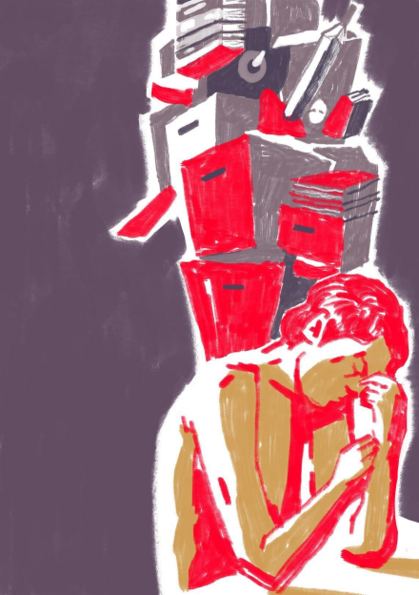ID: This is a portrait-oriented visual. There is a person sitting with a stressed expression
beside the table. They have one hand on their face and their eyes are closed. Their head is bent forwards and their shoulders are slumped. This part of the visual is done in bright colors, but behind them and above their head, we can see the silhouette of buildings. There is an eye in the middle of those buildings. The buildings are overlapping each other and look overbearing.
A Rigged Game
Ankur Gedam
I have switched my career five times by now and I am on my way to making a switch for the sixth time. When I was a kid, the first dream that I had dreamed was to become a teacher. The reason being Meshram Sir. He taught me for two years in primary school—a long time back, but I do remember being excited to go to school and learn something new. I remember being happy in a classroom. After he was transferred to another school, I kept waiting for a teacher who would inspire me the same way Meshram Sir did. It didn’t happen. What I got one after another was unimaginative, dull, lifeless, and spiritless teachers with anger issues. They took everything personally. If I didn’t complete the homework, it was because I hyperfixated on reading Chintu’s adventures (a children’s storybook) that evening. It was on me.
Inventing new punishments for students was their passion and I was an unwilling volunteer. I would be awarded various kinds of punishments—which happened frequently—for not being able to pay attention. Standing in front of where the girls sat was the most annoying. I wasn’t allowed to look down. I would have to look at the girls. I preferred getting yelled at, becoming a rooster, doing sit-ups, and getting hit by a stick on my palms.⁶ This one teacher was very fond of hitting students on their palms with the saddest and toughest stick he could find. I liked him the least. If I couldn’t pay attention to you in class because your teaching methods are tedious, why did I not get to punish you? Meshram Sir would have agreed.
⁶ This story is gendered. The same punishment was given to girls as well, to stand in front of the section where boys sat. The teachers wanted the child who was being punished to feel most embarrassed and ashamed. They weaponized existing heteronormative structures against children for the same. I understand this as an adult that it is therefore a problem. But I am narrating this experience as a child/boy.
Meshram Sir was not coming back. And so I decided to become a teacher myself. That was until my mother told me that I was to become a doctor. She asked me what I was going to do by becoming a teacher. It made complete sense to 11-year-old me. So teaching was out, and ‘doctoring’ was in.
My teachers would often complain to my parents that I never paid attention. If I did, I would score well in other subjects too. The disparity between the subjects I scored well in and the subjects in which I did not was baffling for the teachers. Their little minds could not begin to comprehend why I did so well in some subjects and so poorly in other subjects. These other subjects were geography, geometry, economics, and general awareness. I hated these subjects, especially geometry. No subject gaslights you more than geometry. I have always been suspicious of people who love geometry. I hated these subjects then and I hate them now. The subjects that I loved and scored well in, on the other hand, helped me achieve some success in life. These subjects were Marathi, English, mathematics, and history. Notice something common? Stories.
I loved stories, and for some reason, I loved numbers. I wish my parents had picked up on this and asked me to study arts as Dr B.R. Ambedkar did. However, I do not blame them entirely. They were surviving by themselves. They did not want me to sell flowers, cigarettes, or vegetables. They wanted me to have the best life possible and the only way they knew how was by becoming a doctor. And so I decided to become a cricketer.
School had become dreadfully boring and painful. I was getting bullied a lot, and when I was not getting bullied, I was getting punished. The only saving grace was playing cricket. The reason I was going to school at that point was to play cricket. I would play cricket every chance I got. I would play cricket with my friends, I played cricket with my bullies, and when no one was there, I played cricket all by myself. The walls would bowl and I would bat. Somewhere along the line, I decided I wanted to play for the national team. I struck a bargain with my parents and went to an engineering college. My love for numbers helped me clear the entrance exam. I got into the chemical engineering branch at the Institute of Chemical Technology, Mumbai. The deal was, I would play cricket on the side and give engineering an honest shot. And I did. I managed to clear the first year without any backlogs. But barely. I was crawling. I was not performing well on the field either. Having a foot in both camps was not working. By the time I would reach the practice
ground, I would already be drained.
I wanted to finish the degree. Even though I was not interested in it, I didn’t want to leave it midway. Apathetic teachers, casual bullying, and casteist classmates were not helping. All of this was a routine of normalcy at that point though. What really got in my way was a lack of structure and an auditory processing disorder. Most of the time, I would not be able to register what the teacher said. The instructions that my classmates were able to follow smoothly, I could not. I would fail or fumble spectacularly. The result was being taunted, like “Are you here to waste a seat you got on discount? You could have used your parents’ money for something else instead”.
I dropped out of college in my second year and applied for English literature at the Indira Gandhi National Open University (IGNOU). I would have liked to go to a physical college but this was the best I could do.
I continued playing cricket, but the story was not much different with the cricket coaches either. Half of them did not care and the other half did not know what they were doing. I injured my shoulder due to the lack of a proper training routine. The injury could have been avoided easily with proper guidance from my supposed coaches. I had to go under the knife and do extensive physiotherapy before I could start playing again. But the injury kept coming back and eventually I had to give up.
A degree in arts was not paying my bills, I was getting older, and I was running out of options. I started preparing for banking exams. Mathematics and English were the two main subjects for the exam. Remember the subjects I loved as a kid? This maths teacher there said to me once that looking at my test results it does not seem like I am “SC” (Scheduled Caste). I was performing too well for someone who was SC. Except for Meshram Sir, no other teacher had made me feel inspired, encouraged, and safe. My family’s disgust towards teachers was understandable. Maybe that was why they discouraged my dream of becoming a teacher.
I cleared the IBPS (Institute of Banking Personnel Selection) exam and got a job at the Bank of Maharashtra. I was diagnosed with ADHD just after joining the bank. And here is the thing about ADHD. If we can’t find ways for our brains to be stimulated, we sort of run the risk of dying. At the bank, we were understaffed and overworked. While the crowd’s incessant chattering and cussing, the files piling up and occupying all my desk, and
constant work-related demands from my manager and my colleagues were an assault on my senses, the excruciatingly monotonous and uninspiring daily work routine killed my spirit. On top of it all, there were no breaks other than a half-hour lunch break.
Here is another thing about ADHD’ers—and it’s quite a bit of an issue: Unfortunately, for most of us, ADHD comes gift-wrapped with anxiety and depression. We get no say in the matter. Some of us are inattentive, some are hyperactive, and some are both. I am both. The inattentiveness and the hyperactivity build up, and it needs to be let out frequently. It’s absolutely crucial that we take frequent breaks while working. It recharges our executive function. The more it is suppressed, the worse the anxiety and depression get. The more you are forced to do something you are not designed to do, the more it affects your mental well-being. And traditional academic institutions and workspaces are the complete antitheses to the kind of environment an ADHD’er needs to thrive.
I could not take it for long. I resigned after two years and I went back home. And I realized I was in survival mode. Backbreaking workload, suffocating incense, clamorous crowds, indifferent seniors, selling rich people loans they did not need, my family’s expectations, my own dreams… I was overwhelmed all this time. I had been carrying around the failures with me, all this time. It took me another year to recover.
I spent all my life believing my parents, teachers, seniors, and coaches who did not know what they were doing themselves. I needed better teachers. Teachers like Meshram Sir. Teachers who cared. He used to write us letters, me and some other students, long after he was transferred to another school. In those letters, he would tell me to keep reading and writing. And I loved that about him. While everyone else told me to study, he inspired me to learn and encouraged me to do what I liked doing. And he hadn’t taken it personally when I couldn’t finish my homework. He didn’t care about that. He cared about his students.
I have learned to stick to my strengths. One of those strengths is that I have multiple interests and I am going to pursue them, just not at the same time. Maybe I will follow the first dream I had dreamed of all those years ago and become a teacher. Maybe I will keep working as a content writer. Or I might decide to do something else entirely. I’ll have to figure it out. I wish I knew then the things I know now. I wish someone had guided me, and I wish my life could have been different, and I wish the game of life wasn’t rigged.
But it is, and I have learned to deal with it. You make the best of what you have and you play the game anyway. You try and tilt it in your favor, even if just marginally. So, I will take Meshram Sir’s advice and be a student again. I will read and write and learn. I will be that someone to myself and be my own mentor, and I will begin again.
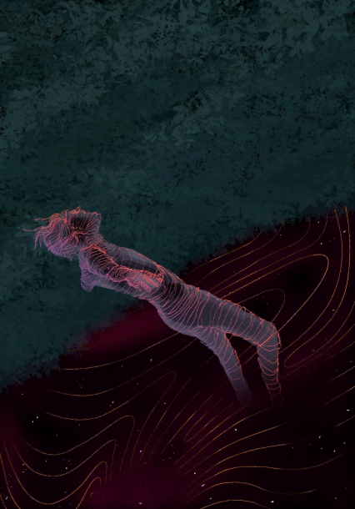
ID: This is a portrait-oriented dark-colored visual. We can see the shape of a person standing, but tilted backwards, with the lines drawn in circles along their body. It's as if the person is wearing so many rings on their body. It looks as if they are floating in space with cloud-like structures and circular patterns around them. They are looking upwards and their arms are open. A few strands of their hair are floating in the air.
Title. No Title.
Anonymous
Writing for the sake of writing. Let’s see where it leads.
This piece is to give you a glimpse of what it feels like to not feel more than what needs to be felt. Feelings with an exact measure! Sounds interesting! Hah! Just some word play. They say a piece needs to be engaging. Trying to create one. No distinctive shape. Let’s see where it leads. The previous sentence could be repetitive but get used to it. We’ll come through it till this piece ends.
This piece. Like the name “this piece”. Sounds childish but at least we started saying it a piece. From no name to this piece, we are evolving and our piece is also developing. See, second para has started without a specific subject. Free flow! Just throwing some words around.
Lost connectivity but we will pull the word “words”. We’ll play with words. What are words? Never have I asked myself this question before. Why now?
Maybe I have so much time. Maybe I have nothing more interesting to do? Or maybe I am just pondering some silly questions. But who knows if we will come up with something interesting which no one might have answered before? Or maybe we are creating some history, or invention, or discovery. Jesus! I am liking this. Just a wandering mind. Yes! I am left with only this. A wandering mind.
Oh god! I think I have just come up with the title of my piece. “A WANDERING MIND”. See, told you, we’ll evolve through this piece. We’ll throw questions and we’ll wander about it, answer it and might not come to a conclusion. A conclusion. After all, who needs
an answer for everything? Sometimes just wandering is enough for us. Amusing for us! Isn’t it?
Oh! Almost covered 300 words and gradually we’ll cover our target. “GOAL. GOAL OF FINISHING THIS PIECE, HEH!” I just felt how much exclamation I use in my sentences. Ah, that’s good. What is life without an exclamation? Bring an exclamation to a person’s life and see their reaction. Did you get what I mean?
In simple words, “make someone smile and let the energy flow through you”. That’s the most amazing feeling. To be happy and make others happy. This is leading nowhere. But still, we’ve some chance to redevelop it because at least we have the first draft of our story.
It starts from nowhere but it cannot end in nowhere. Because it has to end somewhere. Somewhere really beautiful.
These days I’m liking flowers, butterflies, leaves. What about you?
You must be busy with politics, cricket, news, or some intelligent stuff. After all, you belong to the intelligentsia strata of society. Hurts, that word—“STRATA”.
Yes, it hurts us too.
Are we still connected?
Yes, we’re. Where are we heading? We don’t know. Maybe we’ll know in a while. In some time.
Losing connectivity for a while isn’t that bad it seems. After all, we're losing connectivity and reconnecting. What feels better than this?
Ah, wait! My mind is pondering again? Now what is it?
Okay, tell me what is philosophy? How does it help us? How do moksha, nirvana, words like these help us and where do they lead us? These words always sound fascinating to me.
Oh, now we are heading towards philosophy. Planned or unplanned, this turn has been taken and we are feeling great again.
Oh! Philosophy is a mind-enhancing subject for me. The reading is always calming. What is life without philosophy? Both are so interconnected and interlinked that untangling them is really mind-numbing. What gets us here? Why are we so astonished by it? Maybe it always leads us somewhere beautiful and somewhere meaningful.
See. From beautiful, we are now in search of something meaningful.
Okay, out of nowhere, I just feel like talking about my job. About the pandemic and how it affected our life, my loved ones, and everyone around us or even far away from us. Who can forget about the disastrous feeling we had during that time? Told you it’s about feeling, and we had a really bad experience: Losing a job during the pandemic and how all of a sudden, we were monetarily hit. Nightmare! But maybe that’s how disasters feel. By the way, was it human-made or natural-made? God knows or maybe a few people do but at least most of us do not know.
How would we know, by the way? It’s beyond us. It’s beyond everything we see and feel around us. After all, our life is restricted and limited to food, shelter, and family.
About me specifically and how the pandemic and losing job affected me? Okay. I faced the pandemic like most of us did. Like most of the poor people did, who faced scarcity on their face, not the other strata of society who were busy making reels about their best family time spent together or a new pastime—taken up just for the sake of taking.
I faced the pandemic the other way, where managing to meet daily life needs was a struggle. Where they were struggling to get a basic three meals a day. Where getting small tasks done felt so powerful.
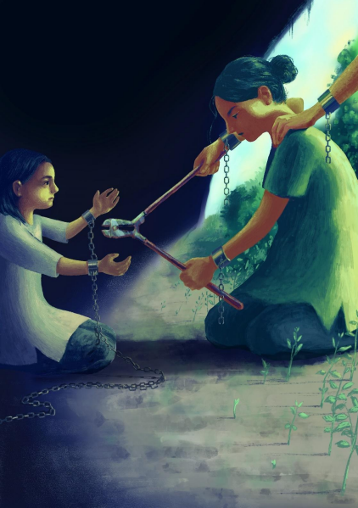
ID: In this illustration, we can see two persons facing each other and sitting on the ground. The smaller person on the left has handcuffs linked by chains on their hands and the long chain is trailing along the ground. There is another larger/older person on the right who has a cutting tool in their hands and is cutting the chain linking the first person’s handcuffs. The bigger person’s hair is in a bun, the smaller one’s mid-length hair is worn loose. A third person’s hand is resting on the shoulder of the person with the tool. Both people on the right also have cuffs on their wrists, but the chains are cut short. There is some grass on the ground and it looks like they are inside a cave or other dark place or under an overhang, with the light coming in from the right side, where a blue sky is visible, trees and plants are growing beyond the shadow.
The Chains Must Break! The Stories Must Change!
Swati Swagatika Das
As a student of philosophy, I often wonder what exactly Dr Rohith Vemula⁷ meant when he called his “birth” a “fatal accident”. Was he questioning Jean Jacques Rousseau’s⁸ statement that “man is born free but everywhere is in chains”? As humans, we do share a common biology; as social beings, we share the ability of thought. It seems our sociality, our being socially situated is a (forced) precondition of our humanness. Yet, both biological and social — along with cultural, political, and economic — phenomena mark our diversity, and sometimes inequalities, from birth itself.
At first, we get a name, and that name sanctions us on several identities: our religion, caste, gender and nationality etc. Then, from birth till death, and after, we become a part of several large societies, and some persons in those societies start training us in the guidelines for their societies — from rituals to taboos.
I am a woman from a backward caste. Being a woman from a particular backward
⁷ Rohith Vemula was a PhD student at the University of Hyderabad, India. He was institutionally murdered in the university campus in 2016, following his social and institutional boycott because of being a politically vocal Ambedkarite. His murder sparked Ambedkarite students’ movements across the country. To commemorate his deep love for and pursuit of knowledge, though he was murdered before even completing his PhD, I call him Dr Rohith Vemula.
⁸ Rousseau is debatably a sociologist and was a political philosopher of the French Revolution. .
caste with a feminine body, my body is considered impure, restricted, and enslaved. The objectification of this body underlines the political role that my body plays in the Brahminical structure that we are living in. This imposed objectification is so cruel that it makes me feel like my body is nothing, and it is not even my own. Society uses my body for its own satisfaction and governs it with its own patriarchal and Brahminical thoughts.
Let me speak out about the relationship of my body with ‘others’. During my school days, upper-caste men would follow me and make comments about me, stopping my bicycle often and threatening me in the name of heroism. In their minds, being insensitive to me would make them look like heroes. It didn’t matter to them how their behaviour affected me. When cis-men harass women in such a way, they do not consider how their actions can negatively affect the woman subjected to their gaze and everyday harassment.
I remember during my school days, a dahibarawala’s (street vendor selling a snack of fried fritters in yoghurt sauce) granddaughter — a minor, backward-caste girl — was raped in a village on my way to school. After hearing this, my parents prevented me from going outside for a couple of days due to the prevalence of such cases on the streets at that time. I was a child, on my way to adulthood, and at that moment I did not understand why I was subjected to such restrictions. Their fear of having a girl child goes back many years — to even before I was born.
My mother never wanted to restrict me, but after hearing such news, she was afraid that I could be subjected to such inhumane violence. She was afraid of the consequences of sexual violence on my career, my honour⁹, their honour, and our lives as a whole. Even though my mom didn’t really restrict me from going outside, she taught me to dress ‘properly’ and behave ‘properly’ to avoid stares as much as possible. I never could fit her ideal of womanhood, as I was raised with both my brothers, my father, and my grandfather. From the way I dressed to how I behaved, nothing was ‘womanly’ enough for my mother. While my father would buy me the same clothes that he bought for my brother, my mother bought “princess” dresses for me. I loved both kinds of dresses, yet I always found myself
⁹ I understand that the notion of honor attached to sexual violence is gendered. But because this was my experience then, I choose to stick to expressing how I felt.
to be a misfit everywhere.
I share a complicated relationship with my mother. My mother understands the meaning of love, and she understands falling for someone is totally human, yet she thinks that only she has the right to choose a partner for me. She has built an ideal partner figure for me in her head, where she lives in denial of my relationships. My mother never appreciated my romantic engagements at all. Back then, I was not just emotionally distant from my mother, but also physically distant primarily because of her job, which was around 400 km away from my village. Even from that distance, she would often guide me about ‘appropriate’ conduct. I despised her because she put a lot of restrictions on me. I felt miserable and unloved because of her behaviour. This resulted in me having a lot of resentment towards her. Now that I have grown up, I realize that she is literally the only person who stands by my side despite everything. The woman who did not appreciate my love life in my childhood has now started to appreciate me, and the choices I am making in my life. This includes my decision to pursue philosophy as a discipline and my personal life as well. These changes have compelled me to let go of all my resentment against her.
There is another change in my outlook towards her as well. Today, when I look back, I realize why she did not appreciate those things in my childhood. The primary reason for her behavior was the constant fear of harm to my safety, well-being, and my life in general. I also realize that without my mother, I would not have been able to reach where I am today. I understand today that raising a daughter from a distance is not easy in this cruel world. Being a woman also, she has lots of struggles in her world as well. She never shares those with me, but today I understand.
Surprisingly, nowadays we share our feelings. One day, in a conversation, I asked her, “Mom, do you hate me? Why do you not love me as you do my brothers? Were you really happy when I came into this world?” She replied that she was very happy and that the daughter is for a mother, the one who understands her feelings. She is blessed when God gives her a daughter. But at that same moment, she also fears how she will raise another girl child in this society.
I remember when I was in school, in the 5th grade, I faced sexual harassment by an upper caste man, who used to be my tuition teacher. That man touched me in a very inappropriate way. He used to ejaculate on my skirt. He used to call me to his kitchen and forcefully kiss me on my lips, spit on my tongue, and try to push his penis inside me. I repeatedly told him that it was hurting me, and he would completely disregard my cries for his pleasure. I still carry that hurt in my body. I can still feel the dryness on my lips. My lips were parched, dry like my skin, coming out with blood because of that fear, that fear that made me think about what would happen the next day if I went to that tuition class again. Along with his disgusting behaviour, he was also manipulating me into not telling anyone about my abuse. I would howl whenever I had to go to my tuition class in the absence of my family and whenever my brother couldn’t be there to accompany me. No one ever understood why I would cry at the idea of attending tuition classes. My parents felt I was making excuses for not studying. The teacher was nice to me in front of people; he would never punish me. This was primarily because he feared that if he misbehaved with me, I would tell people about his actions. When I used to play outside, he used to pee while looking at me. This situation stopped me from playing outside with my friends.
That harassment created fear, and that fear followed me into my teenage years and adulthood. It didn't allow me to go into a relationship. I feel harassment does not just happen outside the family, but it can happen inside the family as well. But the question lingers, which women face this kind of problem? The answer is simple: those who don’t have security, who belong to lower communities, who cannot fight against that abuser in the absence of capital and power among many other things.
Nowadays my mom often tells me about how I was a very silent girl in my childhood, that whatever people said to me, I would obey them. According to my mother, I was a very ‘sanskari’ (cultured) girl child. In our culture, a girl’s silence is considered ‘sanskari’.
After my schooling, I got a chance to study social science. I learnt about society, i.e., caste, gender, race, religion etc. I befriended people whose thoughts and ideas resonated with me. Even with education, my fear didn’t go away, but I tried to overcome my fear and
became cautious about all such possible incidents. I started to assert that no one had the right to interfere in my sexual life.
I am now a supporter of feminism, LGBTQ rights, Ambedkarism, and Buddhism. I do definitely have certain advantages and disadvantages because of being born in a pre existing unequal structure. Every moment, I am reminded of identities that I didn’t choose for myself, guidelines I have to follow, punitive measures if I disobey them, and rewards if I turn out to be an ideal submissive backward-caste woman. But I deny their rules, I deny their punishments.
Growing up, discussing my life story with my peers, I realized I’m not the only woman here, but that many women go through the same situation. We used to hide all these things from our families. At that time, I didn’t know why I was hiding these things, and why I couldn’t tell my parents. Suddenly, a kind of maturity came, when I didn’t have that awareness before.
Why did it happen — I ask myself every day. In childhood, when men roam outside naked, a woman learns how to wear panties, how to cover her body, how to talk with others, manners, sitting position, sleeping position, and how to dress properly. My rights and duties are predetermined. The caste and gender structure has us chained even from birth. It is due to many of our foremothers that we have reached this level of assertiveness. We must ensure today that no one is born in chains in the coming future. In our collective struggle, the goal is not far.
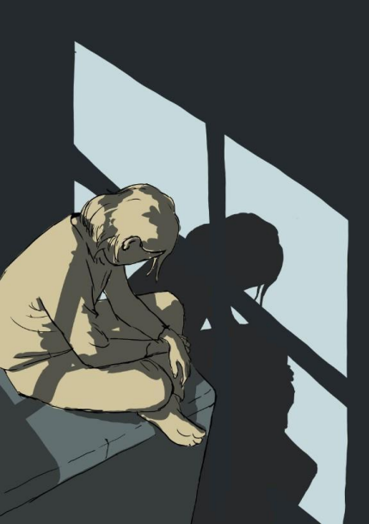
ID: In this visual, a person is sitting with their legs crossed. They seem to be sitting beside a window because their shadow is falling on the adjacent wall, criss-crossed by what looks like the frames of window panes. Their hair is short and loose. We cannot see their expression, since they are looking at their shadow. But from their body language, the way their hands and shoulders look, they look tired. Two strands of hair are falling on their face, the same can be seen in their shadow. The platform they are sitting on and the wall are of a single plain color.
Living multiple identities
Bhanu
Journey towards higher education
I am a first-generation graduate in my family. My journey towards higher education has been quite unexpected. There have been pauses in this journey. I have been more moved with the flow than having it all decided since the beginning as they show in movies. My father is a follower of the Hindu religion and of astrology. He believed it staunchly when an astrologer predicted that I wouldn’t study past 12th grade and would marry into a wealthy family. I am 30 now, have earned an MPhil degree, am preparing for PhD studies, and have decided to never marry a cis-man. My education in the social sciences also gave me activism—not only feminism, but also connecting me to the anti-caste movement. I accepted my queerness, gained anti-caste consciousness, and discovered my disability while pursuing women’s and gender studies for my MA and MPhil degrees. But how did it all begin, I wonder.
It was in 2013 that I decided to pursue a master’s degree in Gender Studies despite knowing that it may not land me a job. I do not come from a well-off family, and being financially independent has been crucial for me since the time I began higher education. (I used to offer home tuition to rich students to meet my expenses since my undergrad years.) I was somehow confident that my degree in English literature would fetch me a job anyways. However, I had to continue to give to be a tutor for eight months after I completed my MPhil degree. Had I not been earning, I wouldn’t have managed to study this far. It’s not like my parents didn’t have money to pay my fees, but I wouldn’t have been able to live a
middle-class life all through my education with my father’s income. Bahujan families don’t spend on women’s education as much as they spend on their marriages.
I started my MA degree with wanting to work on domestic violence, as I have grown up seeing it around me, but ended up writing about women and mental illness. My engagement with gender and health papers was quite appreciated in classes. I did not know then that I had a story inside me wanting to be heard.
Growing up a caregiver
My mother has schizophrenia. I have always known her as a Mad¹⁰ woman, while I was trying to accept her, love her, cherish her, normalize her. What I did not realize then was that I was also normalizing her violence towards me. She has made sexual advances towards me, accused me of having affairs with men around me, including those in the family. I was just another woman for her, who was trying to snatch her space in her domestic realm. I always wished that for once she saw me as a daughter who longed for her love and acceptance. In trying to empathize with her, I did not realize that I was normalizing my own trauma of having lived with a ‘psychotic’¹¹ person.
Caregiving is hard when you are not the one in a position of power with respect to the person you are caring for. There was this one time when I, as a teenager, was trying to learn the correct spellings of schizophrenia and how to pronounce it. Then there were multiple times I would share this big secret with my friends, that my mother had a mental illness. Someone could be my close friend only if I could trust them with this information, only if they could understand this part of my life and family. Initially I would share her suspicion about everyone around her, the fact that she had been admitted to a mental hospital, and then that she was on lifelong medication. My friends would find it surprising because none of this would happen in front of them. They had no idea of what it was like to be mentally ill or to have someone in the family who was.
¹⁰ I use the term “Mad” with a capital M to denote it as an identity category. Seeing my mother’s identity as a woman with psychosocial disability, I being someone who has also experienced madness in relation to her and through my own experiences, I claim it as an identity category. The term “Mad” is used in the context of the Mad movement that started in the US.
¹¹ I use the word ‘psychotic’ while being aware of the ableist connotation attached to it, especially when it comes to women. I insist on using it to express that this was the only language, however problematic, I had to understand her as a woman with psychosocial disability. The use of the word “psychotic” also hints at the inaccessibility of activist language to a child.
Today I myself live with PTSD, anxiety, and depression, have a brother who has schizophrenia, and another brother who has bipolar disorder and ADHD. I can’t say who is whose caregiver, we all seem to be taking care of each other when the need arises. But majorly, my father, my mother, and I are the primary caregivers in the family, I being the only one who is educated enough to assist with decision making.
Being queer and Bahujan¹²
I always knew I was queer even before I knew the term. Years of teenage sexual exploration with cousins and nieces normalized same-sex sexuality for me. So when once in my MA class, the question of same-sex relations came up, to the surprise of other classmates, I quite confidently said that it’s quite common and that I was bisexual. People would ask me questions like when did I realize I was bisexual, and it would confuse me that it was not a common thing for them, while I had grown up seeing closeted same-sex relations between women around me.
I have been in psychotherapy since 2015, where I would mostly talk about my family and my trauma of living with a Brahmin woman at her home for six months — how that brought my self-confidence to an altogether new low, and how her family’s behavior towards me reflected their Brahminical outlook towards me. Not only that, in retrospect I realize that being around her also made me uncomfortable about my masculine side. I started feminizing myself after living with her, as if that was the only means to be beautiful and sexual. Studying at a liberal university and finding my space there only furthered this fitting into the gender binary for me. I started wearing suits and sarees, unlike during undergrad when I would wear shirts and go out with my unwaxed body on my Scooty like a bike rider.
I realized that my experience of staying at this friend’s place was a caste experience only after I came into contact with the Dalit Bahujan Adivasi Collective (DBAC) at Ambedkar University, Delhi. I realized that this struggle towards higher education is generational and not exclusive to women in my community. Men too struggle to pursue higher education in my community as they have the pressure of being the breadwinner of the family.
¹² By “Bahujan” I mean a political unity of Dalits and Backward Castes to fight against Brahminical patriarchy. For me, this patriarchy is also ableist and queer-denying.
Becoming disabled and chronically ill
In 2016, as I acquired depression and anxiety, I also started having lower back pain. On consulting with a doctor, I found out that I have a herniated disc in my lower back. Standing or walking for five minutes would give me back pain. I was unable to even make tea for myself, let alone cook or walk. What this took away from me was my love for long walks, which I earlier used to have holding hands with friends and partners. As a researcher, going for fieldwork also became impossible as I would need frequent breaks from work. I spent two years after my Masters without a job, offering home tuitions. Riding a Scooty for long would also be painful then.
By now I have learned to manage the pain and accommodate my accessibility needs according to my body. But the years of non-functionality it has given me is something I can’t forget. I remember sharing about my back pain with someone on a dating application and the first question I was asked was whether I could have sex. I left the conversation there as I didn’t know what my capacities were anymore.
By the time the COVID-19 pandemic hit, with a nationwide lockdown, my anxiety was at its peak. Twice-a-week therapy sessions felt like 24-7 self-reflection. On one night, I would see snails crawling over my body, while on another I would see myself trapped in a haunted house with bats and crows around. I spent nights crying about having been raped by multiple men, known and unknown. The nightmares increased as the days went by. I was finally diagnosed with Post-Traumatic Stress Disorder (PTSD).
As months went by, my anxiety would end up in high blood pressure for days, which is when I got a psychiatric evaluation done. The psychologist suggested I start medication, but the fear of being on medication, given my family history of mental illness, took much longer for me to get over before I realized that I really need to start taking them. The medicines have their own side effects too. I mostly feel numb; I have difficulty being happy or crying; it lowers my libido; but I am functional. I might slowly be off medication someday as I find alternative means of dealing with my disability, but that’s a long way to go.
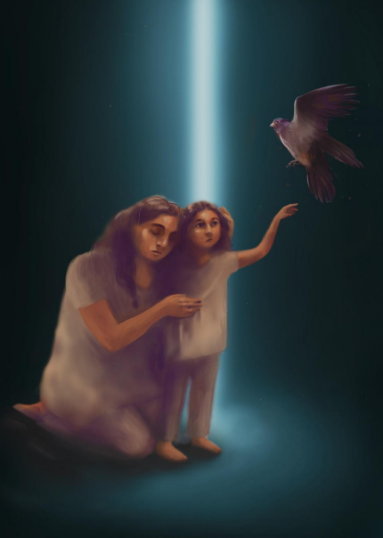
ID: In this visual, there are two people and one falcon flying. One person, who looks older, has loose hair and is holding a younger person. This older person’s eyes are closed and their expression is stern. They have one hand on the younger person’s head and another hand on their torso, holding the younger person closer to themselves. The younger person looks curiously towards the flying falcon. With one hand, they are trying to reach the falcon. There is a single bright light in the background. The falcon is on the top right of the page, with wings open and looking straight ahead.
Owe Forgiveness to Our Childhood
donna (pen name)
She Often in her Darkest Dream,
Finds Herself Unknown to her skin.
But grows with her; Why?
Little she knows the language to speak.
Questioned what it is.
When the future reveals its cruelest light,
Asks her, “Why did the ‘darkness¹³’ never leave me?”
In her wandering, listening to her?
Childhood bid to the butterflies, to go to rainbows.
To be on the lap of the rainbow for eternity.
She challenged the prison and the prisoners’ rest.
Howling the bruises, howling the curses.
Thus finding the Metta — the possible light
No more swallowing the angers within her!
¹³ Not the physical darkness, which made her scared greatly as a child, but an unknown chilling fear that haunts her wherever she goes and never allows her to be happy.
Thy old prisoner needs no carrying…
But its end wonders her!
The broken needs no end, but A start
She kept the hurt in a palace, call her
Begumpura, to end the cry?
As sometimes she thought past her childhood
An impossible everyday remains however dried,
She excels at it, battling on her terms now.
However, her failing is not her worst enemy now.
For her to survive, her bruises turns her knowing —
Which have now shaped her into another prison,
She cries, she wars¹⁴ it, little she could do further.
There is no one now and can be never, it’s a fatal origin though!
One thing she knows now —
Childhood¹⁵ is the mother that carries the burden.
The child promises to bury the burden of a distant law
Not to be inside the burden of manu any more, Yes!
We thus count our forgiveness to our childhood.
Meant to get the one, when passes through our sadness
When childhood remembers the sweaty dream of darkness.
To know the isolation done to her?
To eye what this world of inequality can’t hold;
Her wings, her desire, her beautiful vision.
Her prisoned friends and neighbors,
Their pitted look can never be enough
¹⁴ The word is used to intensify the everyday crisis to fight it, the necessity to resist (not romanticizing the ‘resistance’ per se).
¹⁵ How does a dalit child share or talk about the (first) experience of ‘Untouchability’ in her life? I doubted myself if it was real or my mind was making up stories, thus I was checking it again and again.
To dull her dreams, to build her love.
When she wonders why this world
Of fragmentation, and shadows
Left Alone for a battle like me.
Resisting the meeting —
Of unmet merit,
Of their privileges.¹⁶
This poetry will be the falcon in the sand —
To remind us our belonging,
The strength of our sweat,
The taste of our knowledge.
The road was too slow¹⁷ to know the meaning;
Indeed, crawling is building into re-living.
For a step to start — I remind myself
To owe forgiveness to my childhood
The child who knows her dream is meant,
To be the one that stands for living,¹⁸ leading!
¹⁶ The influence (power) they exercise over us to make us believe what they want, what they like. ¹⁷ Also may be understood with the connotation ‘lazy’ used by privileged society. ¹⁸ The word ‘living’ also means loving one’s (marginalized) self, and her family, friends, partner, and the world she sees!
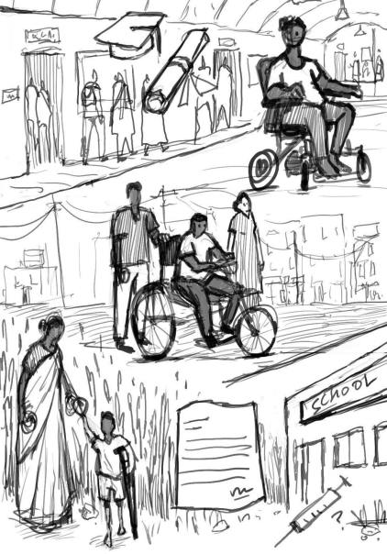ID: This is a sketch of three scenes lined up one below the other. In the first visual, we can see people walking on the footpath. There is a person sitting with a mobility aid in the
road, and behind them is a graduation cap and a degree scroll. The second visual is of a person with a different mobility aid and behind them are two people whose hands are resting on the mobility aid. The third visual at the bottom left is of a possibly young or small-built person with a different mobility aid, holding the hand of a person wearing a saree, who is looking down at them. In the bottom row, in the center, we can see a document which has been signed, and an injection syringe with a question mark in front of a building marked ‘SCHOOL’.
That’s Me, It’s Me
Dr. Kurukhetra Dip
Many decades back, in a remote village of Odisha, far from urban life, the villagers were in the middle of their harvesting season and preparing for their first harvest festival, known as Nuakhai. In the midst of this preparation and on the intervening day of August and September, a baby boy was born to an ‘untouchable’s family.
Everyone in the family was over the moon with joy because when he was growing up, he could give company to his grandparents on the farm, he could act like a brat with neighbors, and importantly he could be jolly with each and every one in his ‘untouchable’ hamlet, or basti. But the joy didn’t last long, and an unfortunate incident struck the family in general and him in particular.
One night, he became ill and had a high fever, and his life turned upside down. Entering new and unexplored terrain, and with lots of difficulty, struggle, and negotiation in everyday life, he started a new life. In the new domain, his journey started with an impaired body, when he was around 2–3 years old, or you can say the onset of disability in his case was when he was around 2–3 years old. It was during this period that his body contracted a virus called polio and, as a result, his body got impaired. This happened partly (i) because his mother was not vaccinated when he was in her womb (due to being unaware of the fact that there is something called polio vaccination) and (ii) because when his body showed symptoms of the infection of the virus (polio), a local quack injected it with something. In the later stage, when his parents roamed around for the best medical intervention, everyone (every medical expert) advised that because of the quack’s
intervention (wrongly treating the symptoms of the body), the body became permanently impaired.
Because of his impairment, now his body became a marker, a marker of differences. Though in the early period, his parents tried their best to get superior medical intervention and ‘correct’ this differentiation, later on they gave up and accepted him in his new life. They became everything to him. His family negotiated and navigated his struggle as their own, became a shield for him, and many times they stood up for him whenever he got bullied by non-impaired people. The acceptance of his new self by his family had a positive impact on him. Now he had to learn other life skills for his survival, like going to school, studying well, and trying to be as independent as possible. Let’s take a peek at how he thinks he has negotiated the everyday prerequisites over time, until the time of noting down this narrative.
He divides the journey of his impaired body into three phases because he foresees that each of the phases has its trajectory and a beauty to the journey.
1. Dependence
2. Semi-dependence
3. Somehow independence
Dependence: In this phase, from the onset of impairment to the early part of his teenage years, he fully depends on his mother and in some instances his grandmother. The dependency includes attending nature’s calls (defecating, washing butthole, taking bath, etc.). Though in this period he could walk with a crutch, it was difficult to attend to the most important task, i.e., nature’s calls. In this phase, his formative years of education also started, from primary school to upper primary school and high school. His mother would take him to every common bathing place like a stream, river, well, etc., while his grandmother would take him to various festivals like Shivratri,¹⁹ the local car festival, or any open-theater program happening in their village, particularly the Ram Navami²⁰ in the
¹⁹ Shivratri or the “night of shiva is an annual Hindu festival where people worship Lord Shiva. ²⁰ Similar to Shivratri, in Ram Navami, they of the Hindu religion worship Lord Rama annually and perform a 14-day play based on Rama’s life story.
village. It is not just his family that stood up against his bullying, but also his peers who played an important role in negotiating with the bully.
He can remember a couple of incidents where his friends stood up for him. One such incident happened during Ram Navami. One day, he went early with his friends, and he had a scuffle with a ‘touchable’ guy for space the friends had captured earlier. The scuffle happened because the “touchable” boy abused him by calling him a “cripple” as well as by calling out his caste name. His friends, who were around, intervened and beat up that guy. Later on, this incident became a larger issue and could only be resolved with the intervention of elders from both sides of the community.
Another incident happened when he was in high school. One of his classmates, instead of calling him by his name, called him “cripple”. In the blink of an eye, his friends confronted that guy. Later on, teachers also called out that guy and announced in school that, from the next time onwards, whoever called him a “crippled man” would meet appropriate action. This announcement yielded very positive results, and he excelled in his studies after that.
Semi-dependence: This little transformation of the phases happened when he got a tricycle from the District Welfare Office. Going outside or to an open field for defecation etc. Though he was still walking with the helping crutch, doing work on his own, he was still depending on his peers, his brothers, and other family members, in terms of going from one place to another, particularly attending college. It is in this phase that his education also moved with the flow, and in time, he graduated and was a postgraduate.
Somehow Independence: This phase started when he was in Delhi for his MPhil program. This was the first time he was introduced to a motorized wheelchair, gifted by an NGO. In this phase, his life somehow became independent, though that too had its side effects. he says.
Just as he said that this was his body, his journey, he couldn’t complain or criticize, in the second phase of his journey, he said that he was more lively, easier, and content with his life, without any worry about what was coming next. In the third phase, life became
easier, and the impaired body further gained weight and was considered to be in stage one obesity.
But the beauty of this journey is that the education that started just to write a letter to his grandparents and uncles, who were migrants laboring in another state, now has seen him graduated, with a doctoral degree, and teaching at Kalahandi University. (That’s his story, that’s my story, that’s me, it’s me.)
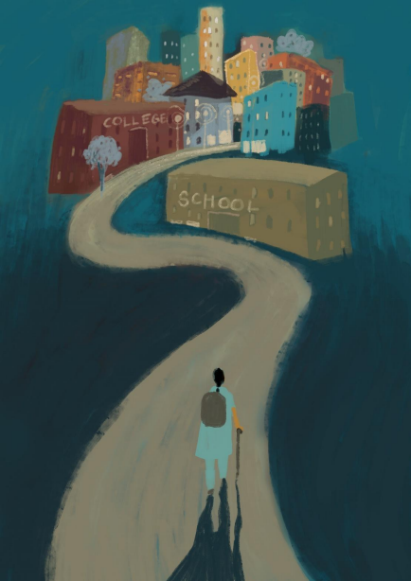
ID: In this illustration, a long path is going towards a city. The city has buildings named “school” and “college”. A person is walking along the path, positioned at the base of the illustration and facing away from viewers, with a school bag and a stick in their hand. They have braided hair and are wearing a salwar suit. Their dark shadow is cast on the path behind them. They are facing the buildings ahead. The buildings are very far from the person. And the person is walking alone, with a staff.
My Journey towards Education as a Disabled Muslim Woman in Delhi Farheen Anwar
My name is Farheen. I have done an MA in education from Azim Premji University.
I was six months old when I was stricken with a fever. I was given medical treatment, but I wasn’t recovering, so I was taken for a more thorough check-up to some hospital. But the hospital staff didn’t do a proper job of treating me. It is said that due to my ineffectual treatment, one of my feet contracted polio. After the polio was diagnosed, I underwent a lengthy course of medical treatment, but my foot didn’t recover.
Later, by the time I was five years old, I developed an intense aptitude towards education. I started asking my family to provide for me in this matter. My mother went to a school and talked about my enrolment. But they and many other schools were unwilling to enroll me, since they were wondering how on earth this girl would manage the commute to and back from school. It was with great difficulty that my mother succeeded in enrolling me. The institution willing to do so was a government school. I then started attending school every day.
I found it difficult to commute to and from the school, since I had much discomfort in walking. I thus took the physical support of two people at a time to make it till school and back again. I would keep one hand on my sister’s shoulder and the other hand on my friend’s shoulder. I would attend school this way, getting exhausted in the process, of which my sweating profusely was a reminder. On top of that, my sister and friend would
sometimes let out to me that each of them was left with a tired shoulder, due to my constant holding on to them.
But they never made a habit out of complaining, and would in fact help me build my mental strength, encouraging me to walk without their support. This appeared an impossible task to me. Then, with the passage of time, I started learning how to play sports, and how to study. Playing sports was proving very difficult for me. Yet my sister and my friend both made a solid foundation for my self-confidence, by bringing into effect special rules that would apply only to me as a sportsperson. This was to enable me to play sports with them, and enjoy doing so. The two of them never let me feel as if I was very different from everyone else. I still felt it, though, since I couldn’t walk the same way as most people do, and I could certainly not run.
However, I never considered myself weak in the ableist sense. Slowly but surely, I became an expert in the sport I used to play. So much so that I began playing with other kids as well. And so, going through the motions of study time and play time, I completed class 5.
Another challenge then arose for me. My friend was enrolled in some other school, while my sister and I were enrolled in yet another school. I still didn’t give up. I now continued going to school by placing my hand only on my sister’s shoulder. This led to me being punished for reaching late, and so was my sister. This is how I completed class 8.
In class 9, my sister and I were put in separate sections. I became totally alone. Somehow, I started walking (and trying to walk) by myself, without any support. Going the entire way, with my extremely heavy bag worsening the situation, I would keep wondering every day when school would end and I would be freed of this oppressively heavy bag. This is how I completed class 12.
I then started saving up money for my graduation, which I managed to get enrolled for, but I then became very ill. My leaning on just one foot for walking had impacted my spinal cord, so much so that my lower half, i.e., both my legs and feet had become numb, leaving
me unable to either move about or sit up, let alone walk anywhere. I had become totally bedridden.
Once again, I was taken to a hospital, where the doctor I saw thought I just couldn’t recover. People around me also thought I was in paralysis, and had no chance of recovery. Despite all this, I buoyed myself up by undergoing extensive treatment, and got admitted in said hospital.
I remained admitted to the hospital for a month. But my treatment went on beyond that, and it actually took me three years to recover fully. My studies had, of course, suffered a setback. I had been unable to pursue my graduation. Now getting enrolled at another college, I started going there by myself. I had nobody from my college to accompany me on these commutes, because nobody was willing to walk at my pace, since I walked very haltingly. Even so, I had successfully resumed my education, and I went on to become a graduate.
Then I applied for a master’s degree, took the exam, went for an interview, and cleared both. So I gathered all necessary documents, preparing to travel to Bangalore, where my institute happened to be. This requirement was a challenge for my family, since I had to be away from not just our household, but our city. It took a lot of convincing from my end. Others were finding it difficult to align with my viewpoint, and I with theirs, since there I was, a disabled Muslim woman, where Muslim women in general don’t have permission to go outside their homes, let alone study, their existence being defined by the veil. And here I was, having broken and still breaking all the rules set for Muslim women.
I then decided that no matter what concessions I had to make at that moment, I would go to Bangalore. Come what may. To get the ball rolling, my younger sister and my mother accompanied me till Bangalore, and bid me au revoir there. Subsequently, I commuted to and from Bangalore by myself, thinking to myself “So what if nobody is with me — Allah is here with me, and while Allah is with me, nothing untoward can happen to me”. I completed my master’s this way, paying for my entire higher education by myself.
Translated from Hindi to English by Nirbhay Bhogal and Rani Sinha.
ID: There is a person sitting crouched in the corner of a room. They are holding their own wrist with the opposite hand and their legs are crossed at the ankles, knees raised. Their head is bent and buried in their arms. The floor they are sitting on has stacks of books. Some books are open. There are masks lying around them. There is a certificate rolled up, with a ribbon, lying next to a graduate’s convocation cap. A pen is also lying on the floor. At the top of the illustration, there is darkness and lots of eyes are looking down at the person.
Changing Masks: Living with Imposter Syndrome
Kamna
I came back to my parents’ house from my first job interview and kept my bag on the now shabby-looking table. In the corner of the bed, I lay with the unbearable heaviness of my body without changing clothes.
While my body tries to get some rest, someone quietly sneaks in: “Why did you use the Forrest Gump reference in the interview? Were you showing off that you have seen one movie in English and that you can fully understand it? Why will they hire you? You have never worked before? What if they hire you? They will find out that you are a fraud and that you know nothing.” And I don’t remember when I fell asleep. Sleep has always been a comfort to me.
Rejection has always been an acceptable and comfortable experience for me. I accept it with open arms because then, I get to be in my room, and my reality, my nastiness,
my lack of ability, and my ugliness stays within this room. My family members probably know this part of me quite well, and I often wonder if this is why they have rejected me. I am convinced that once people get close, they will finally know what a horrible person I am, that my body reeks of lowliness, the absolute truth about my fatal birth, my caste. They will leave, confirming what I have come to believe about myself. It is scarier and more anxiety-inducing to be accepted into a new job, educationall course, or any relationship than to be rejected, which is, as I said earlier, more comfortable. Acceptance would mean that they will finally know the truth about me, they will know the truth that I have been trying to fight for such a long time.
Every time I try for a new job, a new degree, a new fellowship, a new career, a new friend or a partner — I am trying to pass. I am a trespasser, my existence is judged, and I remain unwelcome in many of these places. Fear lurks behind me, like a heavy brace on my leg, that I will somehow be discovered and shown my place.
I try to enroll in degree courses that I feel are beyond me, hoping that through these prestigious degrees, international fellowships, and projects, some of the prestige will rub off on me too. Just enough to give me my dignity back.
People like me don’t have careers, they don’t deserve a life like that. I should stay within my limits, my brain tells me.
To avoid being found out, I work hard, hard like a ‘caste-privileged’ person perhaps, so that nobody can tell me that my work carries my essence, my caste. I work so hard till I actually feel I am working hard, for if I don’t feel it, it becomes a sign that my innate ‘caste-induced laziness’ is taking over. I am told that it is in my blood, and that I am not fit for intellectual labor. The conditioning reminds me that my status in society is not congruous with the kind of dreams I, a Dalit woman, have! So, when I pretend to be a research scholar, I chase the feeling of working, working hard, working extremely hard, so much that I feel it in my bones. This chasing of the feeling of working hard has made me drop to the ground unconscious several times and has given me chronic illnesses.
Whenever I approach a new task, a degree, or a new job, I start from scratch. I discard every skill, every experience, and literally everything that I have learnt in the past seven years or more, and only my caste-induced not-knowing-anything and being-nothing
remains. My heart feels hollow, my chest feels empty, and I carry this heavy boulder like Sisyphus wherever I go.
This not knowing enough, not being enough, and not knowing anything at all seems familiar to me. This has made my body and mind both suffer, suffer for years now. I feel there is a wide gap between my body and spirit. I feel like a lifeless body carrying a huge stone slab almost every day when I wake up. Some days I hope to put that slab down, while others I hope to get buried under it.
This has become a reality in my life—my experience of apparently doing so much, having a glittering CV, a professional resume for jobs, that I don’t even relate to at all. For every interview, I carry that piece of paper that means nothing to me. Still, I send it over to the employer with the all-encompassing fear of finally being found out, because what lies beyond the contents of that piece of paper, with multiple entries about my education and work experience, is my innate reality, my inferiority that is visible at the moment you lay your eyes on me.
Some days I wonder why I even apply for jobs and degrees when they do absolutely nothing for me. In the past few years, a part of me has maybe even accepted it, I apply for fewer conferences, and reluctantly enroll myself in educational degrees, jobs, or anything. I seldom leave this room where I lay in one corner. This corner seems like a safe space for me, a space where I lie with my filthiness. The only place that lets me be there despite my caste.
****
Perhaps one day I will shatter the mask that relentlessly weighs me down. It reminds me that I need to cover up — a mask that leaves me feeling soiled and inferior. I will stand fearless before those who forced me to wear a mask, to hide, and those who convinced me there was something wrong with me. I will also confront all the thoughts residing in my head, living rent-free in my mind, making it a decaying attic filled with cobwebs and dust.
One day, when I clear away the debris of this mask and its lies, I will behold my true self in all its glory. I will seize every aspect of my being and declare to the world: I AM! I AM! And I AM! With that declaration, I will set my spirit free. I will embrace my choices. With
courage in my heart and fire in my soul, I will carve my own destiny, with every step and decision leading me closer to my dreams.
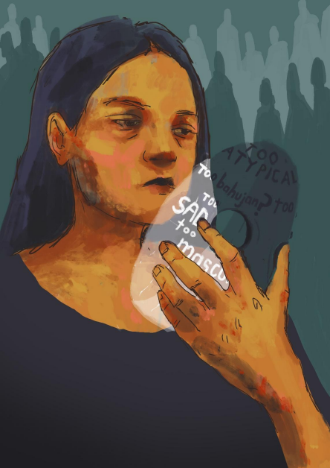
ID: This illustration has a portrait of a person. They have long hair. They have a sad expression. They are holding a transparent mask in their hand. They are looking down towards the mask. The person is wearing a round neck black top. There is text on the mask which says “too atypical”, “too Bahujan?”, “too sad”, “too masculine”, and more that are incomplete. Behind the person, there are shadows of rows of other people in the background.
My Journey of Unmasking: Caste, Gender, Sexuality, and Disability Nay
Trigger Warning: physical abuse, ableism, casteism
The ‘gifted’ love child
It all started when I was born as the “love child” of inter-caste parents. Both of my parents were Bahujans but from different castes. This meant that their marriage was not approved by their family or by society. Since they were outcast by everyone around them, all they had was me. They decided that they would try to garner their acceptance in society through my success. This meant that I’d have to appear perfect by any and all means, and that my disabilities were to be “corrected” by flogging and shaming.
Apart from them wanting me to be perfect, they also wanted to show the world that we were a fully functional family. But behind closed doors, it was a completely different scene. We were extremely dysfunctional as my parents slowly started falling out of love. Without the support of family and society, they took out their anger and frustration on me. Like most Bahujan families, physical violence ran in our family as well, and the only way I could escape it was by doing whatever they wanted me to do.
I remember only fragments of my childhood, and most of my memories are from when I was beaten black and blue by my parents. I was the straight-As, ‘gifted’ child to the world, but it meant that I had to mask a lot of things. One of these was my neurodivergence, particularly my ADHD — the ‘inattentive’ type. My parents thought that my ADHD, especially my lack of passion for certain things, and my executive dysfunction could be
corrected with beating and flogging. I did not know how to tell them that I was not lazy, but that I could not bring myself to do certain things because my mind did not let me do it. So, I had to mask my ADHD, mostly out of the fear of being beaten up, and partly because I was made to crave validation.
The darkness factor
I still remember the day I realized that I have night blindness. I was in sixth grade and we were visiting a family friend for dinner. The power went out right when I was about to take the stairs to their door. I was fumbling in the dark, trying my best to see something. I heard my mom asking me what I was doing in a completely irritated tone. That’s when I realized that I was the only one who wasn’t able to see the next step, while those around me could actually see me fumbling in what was total darkness for me.
It took me 14 more years to finally get an official diagnosis, and for my parents to accept that I indeed have night blindness. And for all those years in-between, I had to mask my night blindness for fear of being shamed. Just like how my parents thought they could “cure” my “laziness” by hitting me, they thought that they could “correct” my night blindness by scolding me whenever I stumbled in the dark. If I happened to trip over anything on the floor in the dark, their first response was to scold me for not watching where I was going. So, I learnt to walk as slowly as I could in the dark, and mask my night blindness as much as I could. But this left me with a severe anxiety of walking in the dark, and even of stepping outside the house after sunset.
A series of confusing feelings
It was almost around the same time that I started getting a surge of confusing feelings. I never felt any sort of attraction towards any guy of my age. But like most queer people, I had a crush on one of the English teachers in my school. She was to me… an angel treading on the Earth. Since most girls in my class used to say that the teacher was beautiful, and that they wanted to be like her, I thought that I was also feeling the same. But it took me years to understand that I was crushing on her. Somehow, my early teenage self felt that everyone wanted to be liked by their English teachers.
As I grew up, I could not hold myself back from feeling attracted towards some of my teachers. During my mid-teens, I realized that I felt some sort of way towards these teachers, different from how I did with anyone else. There were quite a few times when my teachers had caught me stealing a glance at them. Their expressions and the way they adjusted their sarees made me feel like I was doing something wrong. So I learnt to mask my queerness even without knowing what it was, and I never told anyone about the crushes or my feelings towards them.
Pastel-coloured performance
My transness, on the other hand, was completely repressed right from when I was a kid. My mom took pride in me being a “pretty girl”. My long hair and my pastel frilled gowns reeled in a lot of compliments for my mother. Even when I was not always comfortable with the dresses and the enforced femininity, I had to mask all that and put up a show for people. I had to be a living, breathing Barbie doll, so that my parents would not beat me up. I vividly remember my dad slapping me when I told my mom that I did not like my hair down for a picture.
It has only been two years since I have got the vocabulary to describe my transness and since I stopped masking my gender identity. It was such a relief to finally come across the term “trans non-binary” on the internet, and to know how well it described my feelings and experiences. “Trans non-binary” to me means that my gender is beyond the binary genders, and that I don’t have to choose between one or the other. The exhausting feeling of having to confine myself to one gender finally went away when I got to know about the term “trans non-binary”.
My parents still don’t know about both my gender and my sexuality identity, and I am sure they would not be accepting of it. But I am done with the compulsory cis–heterosexuality, and I am living my best queer–trans life. I have also come across a few Bahujan queer– trans people, from whom I constantly learn a lot and find a sense of chosen family.
Don’t ask; don’t tell
Being a Bahujan in Tamil Nadu comes with a set of relative privileges. But my parents didn’t want the people around us to know about our caste location. In fact, my mom felt
relieved whenever someone asked us if we were Brahmins²¹. Being a middle-class family with a single income didn’t stop her from putting me in a convent school, as she wanted me to pass for an upper-class, upper-caste child.
Being a half-Tamizhian (from the Indian state of Tamil Nadu in origin, where the language spoken is Tamil) and a half-Malayali (from the Indian state of Kerala in origin, where the language spoken is Malayalam) was in itself quite confusing for the little me. Add having to pass for an upper-caste, upper-class person to the lot. I did not understand why we had to mask our caste location to our house owners and those around us. I didn’t even know what Bahujan meant and what our caste location meant, as my parents never talked about it in our house. But I started understanding why they did what they did only during my master’s degree.
Against my parents’ wishes of wanting me to get into engineering or medicine, I ended up choosing humanities, hoping that it would help me come across like-minded people. I ended up getting into a central university for my master’s course, and not a single day passed without me regretting the decision. Like every Bahujan person, I was made to feel ashamed for claiming reservations²² by my classmates and professors alike.
Ever since, I have been skeptical of joining these so-called prestigious institutions to work towards my PhD. Even with a JRF²³, I feel that I would be looked down upon in these institutions simply because of my caste location. Now that I have experienced enough casteism from neighbors, classmates, acquaintances, and strangers, as mentioned in the few instances above, I can clearly see why my parents wanted me to mask my Bahujan identity. I understand that my parents wanting me to mask everything that is deemed “different” has its roots in casteism.
²¹ The caste system is a hierarchical practice of segregating human beings based on their birth, and it is prevalent in most parts of India, South Asia, and everywhere that Indians move to. Brahmins are among the highest order in that hierarchy and they have generationally had control over knowledge production.
²² An affirmative action in Indian policy for those who have been marginalized on the basis of caste for centuries.
²³ A government fellowship for students who are willing to pursue a PhD.
I still struggle with fully embracing all of my identities. Claiming all these identities sometimes makes me feel odd and distant from society. But I am learning and relearning to define as well as celebrate the parts of my identity that I once had to mask. So here I am, taking pride in being the Bahujan, trans, non-binary, neuro-queer person that I am.
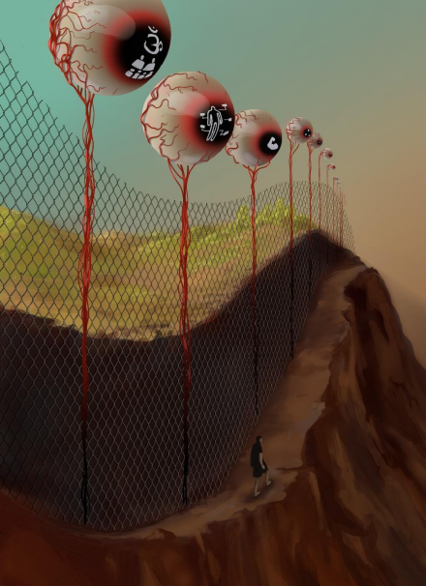
ID: In this illustration, there is a landscape which has a mountain and greenery. There is an open sky. But the mountain has been cut to make a walking path along the steep drop. Beside the path, there is greenery, but the greenery and the path are separated by a tall wire fence. A person is walking along the path. There is a shadow forming beside them. The posts of the fence are topped by an eyeball-type structure with red veins. Each eye has a different illustration reflected on the iris: the first one is Om (the primordial sound written in Hindu mythology) with several people drawn under it; the second one has a human silhouette labelled with different blank tags pointing to different body parts; the third one has a flexed bicep drawn on it; and the fourth one has three dots in a triangular formation on it. From a viewer’s perspective, one can see the eyes and fencing getting smaller with distance.
Disability is not a Problem, it is a Situation: An Illustration of the Socialization of Disability
Ram Singh
I say disability is a situation because, for instance, in a room without lights, a sighted person becomes disabled, and in a room full of loud noises, a visually disabled person becomes further disabled. Since much of society has been politically, historically, socially, and culturally disabled, it becomes difficult for them to understand others’ capabilities.
I grew up in an extended family. My father was the caretaker of all family members. I was the first child of my parents. And I was born with a visual impairment, which has been the greatest mishap and catastrophe of my parents’ life. The family’s societal approach was totally Brahminical in nature, and made my mother’s life miserable. As a housewife, my mother has kept working like a servant for the entire family, and has attempted her best to let me live a better life. On the death of my maternal grandfather, my paternal grandmother and her sister said that it was the death of a dog. This behavior was not opposed by my father. Their mental approach was also ableist when it came to making me a part of their family decision making process.
Concurring with Hindu mythology, my blindness was a sin for them. It was considered to be a punishment for my past lives. The social model of Indian society has
evolved around this understanding. During the initial phase of my childhood, I had been forced to follow their devout worshiping status. But as I grew up, my education made me realize that maturity has strengthened me to get rid of this. I can never ever forget those days when I was regularly called “Surdas”²⁴, “bechara andha”²⁵, “apne bure karmon kaa phal bhogne wala”²⁶, and so on. This pain started to become more pressing when my family used to exclude me, considering my blindness, from essential work that could easily be done by me.
It happened when I was in the 6th or 7th standard. One day, my younger sister, my parents, and I were sitting together and having a discussion about something. Abruptly, I asked to bring something from the cupboard. But I was denied access to the cupboard by saying, “Kyonki tujhe dikhai nahi deta hai, tu koi keemti cheez kahin gira dega. Vahan sara zaroori saman rakha hota hai. (Since you can’t see, something important will fall. Since we keep all our essentials there, something might be lost.)” Yet my younger sister was permitted to do anything, without asking for permission. This occurrence was greatly agonizing for me, and I chose never ever to touch that particular cupboard and those essentials, indeed, not even if they were to ask me. And I would bear all hardships to put myself in a very strong situation where I could have my own privacy. While writing about all these bitter realities, I would also like to say that I did not have any privacy at home. Therefore, I felt at home in hostels rather than in my hometown. Lately, I have also realized that it was not my family’s fault. It was actually the ablest and Brahminical nature of society which victimized both my parents and me.
All my schooling had been completed in special schools for the blind. So I did not confront those ablest segregations at that time. After completing my schooling, I entered my graduation course at a very prestigious Delhi University college, Hindu College. The name itself is Brahminical in nature. Discrimination was also there in various forms.
In my first year of college, I had often been made to realize my disability. I remember the initial days of college. Once, when I was trying to get familiar with the
²⁴ Surdas is a reference to a blind devotional poet and singer who was active in 16th-century India. ²⁵ Translation: poor blind person.
²⁶ Translation: a person who is bearing the consequences of his bad deeds done by him in his past life.
college campus, and we were walking to attend class, one of my classmates said, “Since he is blind, he can't walk fast. He will fall down. Walk slowly, guys.” With every passing day, I had to prove my ability. However, some of my classmates were cooperative and helpful, like Prashant, Vaibhav, Tanmay, Prince, Daizy, Ariba, Drishti, Akshay, Vibha, and Surbhi. I would also like to remember the game changers during my college life, Professor Kanchan and Professor Bhupendra. Since I was from a Hindi-medium background, they gave me an open platform to improve myself without caring about my broken English, along with helping me to improve my typing skills.
I was an active student. I was also the best student in my hostel, as I was awarded. However, I have been opposed to participating in some hostel occasions considering my blindness. I was able to participate, but it always left me helpless and crying, where my disability was stronger than my ability. One day, some names were nominated for anchoring a department fest in my college. When I offered my name, one of my classmates said, “Tu anchoring kaise kar sakta hai saale, tu to blind hai aur doosron ke expressions kaise padhega? (How can you be an anchor? Since you are blind, how you will read others’ facial expressions?)” And I was denied. While writing all this, it is very difficult to control my tears.
When we were fighting for our accessibility rights in 2018, during my third year in college, our principal bluntly and publicly said, “For some disabled students, I cannot put my college at any risk. And we cannot make the structural and systemic changes.” During those days, I found myself alone with my friend, fighting for our accessibility rights. I was publicly threatened with being rusticated for fighting for accessibility concerns. But by then, I had been able to realize that crying under the blanket should not be any more my way.
In Hindu College, there is a musical society called Alankar. I appeared for the auditions in 2015–2016 in vocal (singing), piano, flute, and mouth organ (harmonica). I was the only one who was participating in multiple activities. I cleared the second round quite comfortably. Then this heartbreaking incident took place when I was nearing the end of my second year. At the end of my fourth semester one day, when we were having our dinner, a Brahmin guy who was sitting just in front of me (who was also the vice-president
of the Alankar society during my audition) told me that I was denied selection because of my blindness. As he said this, everything was frozen for me. He continued, “There are multiple travels in a day. And a person like you, who cannot see anything, how will you be able to manage all these important musical values? How will we be able to maintain our status?” And he left. I stood up and left my dinner in-between, and quickly went to my room, and cried from the unbearable pain. For a few days, I even avoided eating in the mess. Still I cry whenever I remember this incident. Anyways. I completed my graduation in 2018.
I entered a master’s degree course at Jawaharlal Nehru University (JNU), Delhi, a premier institution for social sciences and languages, in the year 2018. The strength of my master’s batch was almost double that of the undergraduate course. But the inclusive people were very few. Therefore, I never felt like a part of my class. I didn’t have any friends like my other able-bodied classmates, who used to travel and sit together frequently during my master’s classes. However, the occasional support was always offered considering my limitations. I had been well-supported by Professor Rajan Kumar and Professor Rajagopalan during my master’s. During these 2 years, I often felt alienated and separated from class activities. It is said that the struggles are endless, and the people who have struggled, only they can realize that pain. I had been supported by either my fellow blind community or the Ambedkarite²⁷ fraternity during this time. I had never ever been included in any class or school activities by anyone during my master’s course in JNU except for giving votes during the students’ body elections. And that also continued till I came and registered my vote. The rest was lonely.
During 2020–21, after the pandemic’s first wave, I was also denied my PhD interview by some brahmin professors, an incident which almost lasted for 30 minutes, in order to support an upper-caste guy. This actually sent me into depression for a few months. But time has all the answers. I have gathered all my strength. And I have worked hard. I
²⁷ Ambedkarite fraternity: The people who associate their life with Dr BR Ambedkar’s thoughts. All the marginalized sections, including people with disabilities, stay united under the ideology of Ambedkarism in JNU.
was able to restore my admission just after 10 months in the same year. This recovery phase was quite tough for me to deal with.
However, disability has become my ability to move ahead. Everything has been immensely challenging. And my life’s journey till now has not been at all easy. While writing my own narrative, my hands freeze many times. My tears have also tried a lot to capture space. But I must say, the resistance should never come to an end.
A special thanks to Saathi Kamna for being the biggest motivation, mentor, and booster for me. I thank the Sambhavana organization for being the pillar of my strength since the day I came to Delhi. I extend my gratitude to my partner as well, since we share similar pain due to societal disability. I also thank everyone for the support they have given. And I am thankful for the platform of Crossroads where I could share my experiences.
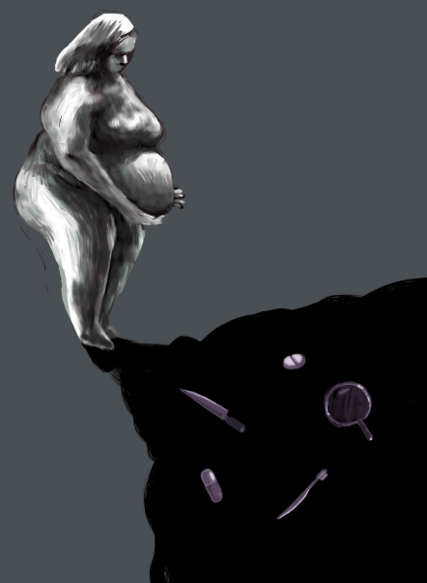ID: In this illustration, we can see a person standing. They are holding their large stomach with both hands. There is a dark black shadow which seems to seep out from the person’s
feet. There are illustrations drawn on it. They consist of a knife, medicines, a toothbrush, and a mirror. The person is looking down at these illustrations and has short hair. This illustration is wholly done in greyish and black tones.
A Belly Story
Rani
Trigger warnings: Mentions of self-hatred, fat hatred, medical ableism, body shaming
I was walking towards the library and this stranger shouted “Moti, kam kha!”²⁸ Just a few steps later, another voice followed me and pierced through my ears, “If I were you, I would exercise daily.” My palms started sweating, and I realized something pushed me very hard. I almost fell down and couldn’t keep my head up. At that exact moment, I froze and my legs refused to move. Tears rolled on to my cheeks and I could feel the cold wind even though it was a blazing hot summer day. Suddenly I realized I was late for my lecture and I needed to go back to my classroom as soon as possible. As I moved towards my classroom, I saw my classmates writing down notes — I was late. I entered the class and tried to fit into the small chair, my belly was very much visible but I soon tucked it in my crop top. I wasn’t wearing a bra so my nipples were visible. I hid that with my bag and started noting down whatever was written on the whiteboard in front of me. After 15 minutes, I quietly stepped outside and went to the crowded cafeteria. The crowd was such that you couldn’t even put one foot inside. I went back to the classroom where a couple was engaging in some intimate act. I ignored them and walked out of the room. Just when I turned to leave the room, the man said loudly to his partner, “Don’t get fat like her, otherwise I will leave you.” I shouted back “Bloody insensitive!” and left the classroom in such a hurry that I didn’t realize that I had left my water bottle back in the classroom. I never went back to collect my water bottle.
That day wasn’t unique, because every day at the university went like this. I wore short dresses every day to my campus and I love a faded blue dress that I bought from
²⁸ A derogatory term used to abuse fat people. Literal translation: Hey, fat person, eat less!
Janpath²⁹ market at the heart of Delhi’s own heart, Connaught Place. Light colors plus heavy arms were a total no-no for me, still I bought that dress. Primarily because of how much I loved it. I decided to ditch the bra that day because it felt like it was choking me. I felt like Rose in the movie Titanic, being tightly constrained by the corset. I felt free for the first time in my life and the stress of getting off those bruises left by the straps of my bra on my shoulders was finally gone for good. I tried that dress in front of the mirror and was happy that my belly wasn’t visible anymore.
As I logged into my Instagram account, I saw photographs of models and even some plus size models, but they all had flat stomachs, and there was no belly. I cut a long piece of cloth and tied it around my waist and tried to squeeze as hard as I could but still, it came out. I was tired at this point and took the end of my toothbrush and started poking in my belly so that it went inside. My belly hurts, and it hurts; what hurts, even more, is to see my belly in the mirror.³⁰
My bathroom mirror recorded all those disgusting sessions of me looking at my belly. I took the same end of the toothbrush and put it so deep in my mouth that all my food came out, and again I tried. This time nothing but a watery and sticky substance came out, I was exhausted and as I touched my belly, it was still hanging out, showing all the stretch marks. This belly is attached to me like a parasite and no one in the world wants this inhuman existence to exist on this planet. I feel like an overblown balloon that doesn’t know its limits, and as one gynecologist commented on my belly, “It’s going to burst.”
Doctors call my belly an epidemic and a problem to be solved, and prescribe medicines to me for losing this belly as soon as possible. I have changed about fifty doctors in my entire lifetime, and all they seem to notice about me and my ailments is my ever-growing belly. My parents told me to eat less and do yoga but nothing ever changed the dimension of my belly. Even certain dresses and gowns don’t agree with my belly. I once posted my belly
²⁹ Janpath is a bustling urban market situated in Connaught Place. Connaught Place is also known as Rajiv Chowk, and is a financial and commercial center in New Delhi, India. Janpath has a variety of street vendors and small shops selling jewelry, footwear, and clothes.
³⁰ The author of this narrative is neurodivergent, disabled, and chronically ill and is going through a process of grief and understands that this is a statement of self hatred.
pictures on Facebook and someone made a comment that “he will puke over my belly”. I think I am growing a thick skin, or is it just that I don’t want this belly to exist in the first place? Bellies like mine are meant to be cut and thrown, and people who have bellies like mine don’t come out as often as I do. Knives don’t cut my belly, as I tried this multiple times, with both blunt and sharp ones. The kitchen knife is my friend, and lots of metformin medicine is my friend. In the last week of October, I took four doses of metformin and used a knife to cut myself—still, my belly stayed like a parasite, though my vision got blurred.
****
My belly stayed with me as I grew big. Still, I hate this monster. My belly is a very visible sign of taking up too much space in this world, which doesn’t have space for people like me, people who have so many cysts inside their belly, and people who have scars all over the belly. My belly has tiny hair and, if she could speak, she would say she is in a lot of pain because a war is going on inside my body. A war where there is a lot of bloodshed and still everything appears to be calm on the outside; there is so much chaos, and still a long silence persists outside. Even a hot pad can’t calm the storm and the violent scarring inside of my body. Still, this huge round pot of my belly, as others like to call her, is holding on to the thread of hope that she will shrink and make herself smaller, even microscopic. My belly hangs and I don’t know why she hangs — is it because of all the weight that she is carrying inside? Or because the war inside my body ended finally? Not even meds can reduce the bloodshed and pain inside.
I bleed and my belly growls as if the secret is out, and I empathize with her, thinking that all this time I blamed her for being so visible, for being so outrageous, for being defiant. My belly is a rebel even in the midst of so much tension and war going on. Of course, she has put on weight because of the bloody war, my own body is my own enemy, and is an enemy of my belly.
Belly, stomachs are warriors, but they are still objects of disgust, so everyone wants to get rid of them, so starvation is the only method prescribed by doctors and family members. One of my aunts told me “no man would marry a woman who has such a huge belly” and I thought finally I am undesirable to men, finally they will leave me alone. All
this time, I wanted peace and [a] life free of war; my belly has achieved this. Men don’t like big bellies, they prefer tiny stomachs, but my belly doesn’t care all about that because she is here permanently, whether people like it or not. My belly is my shield and yet I am disgusted by her. She doesn’t spill the secrets of bloodshed happening in my body; still, she is not my friend, because she has embarrassed me so many times by hanging out freely — why doesn’t she understand that the world hates her existence so much that death is preferred over a very visible belly.
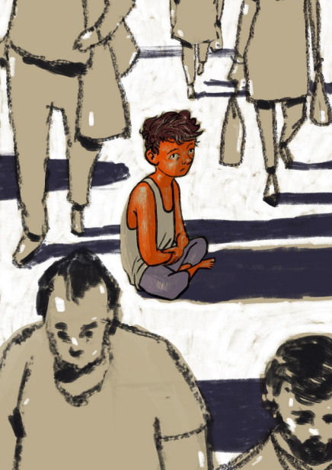
ID: In this illustration, we can see a crowd walking. The bottom left corner shows a person without expression, with a receding hairline. The head and shoulders of another person, bearded, are partially seen in the bottom right corner. Three more people can be seen walking into the top of the frame, only their legs and slippers visible. All these people are sketched mainly in outlines and minimally shaded with a soft, blunt pencil, and in greyscale. There is a child sitting in the center of the visual. The lines used for drawing the child are sharper, darker, more fluid. The drawing of the child is more detailed, precise and coloured in neatly. The child has messy short hair and is wearing a baniyan (vest). The child is sitting with legs crossed and arms folded over them. The child looks underweight, and is looking towards the left with a helpless expression.
Whose Problem is This?
Runa Biswas
If mental health is a problem, whose problem is it? And how is one to fight it? I am Runa Biswas, and I want to tell a story from my village. I live in one of the backward villages of Morigaon, where seasonal flooding and bad infrastructure are the major concerns that we struggle with. Ours is a village with a diverse population. I come from a Bengali (from undivided Bengal, a state in eastern India, in origin) agricultural family, settled in the lowlands of Assam, in an area named Ezalgarh. There are Bodos, Assamese, Biharis, and Muslims sharing the neighbourhood, with all the community depending heavily on agriculture. Though the place is rich in growing multiple crops, the farmers get affected by yearly flooding and by the unpredictable Brahmaputra river. They survive through incomparable human skill in the mushy land, which is yet to see the face of development in terms of proper road facilities. Sometimes I feel proud of my village people that, despite so much adversity, they still manage to take care of their children’s needs and education. During heavy flood situations, even providing a boat for students to attend schools becomes a villagers’ concern. In such a situation, one can imagine our quality of education and quality of life, which I want to share through my writing.
I have completed my master’s degree in Assamese, for which I give credit to the effort my uneducated farmer father put in, and my mother, who supported me. Our family
is a little well-off compared to most of the families in the village in terms of education, as we have a few educated employees, and we are connected to city life. Still the number is a handful, just like how we have few educated individuals in our village. I wonder how much they have struggled to have that, as much as how we are still struggling to complete our education.
Most of us could complete college education, but without any proper job facilities. However, students nowadays do not wait for jobs and service opportunities any more; rather, they are setting up small businesses in the nearest towns and cities. Sometimes, they also go for manual jobs in big cities. I see in the morning the adult members of the families prepare for their farming routine, take jol-paan (breakfast, usually watery rice and vegetables), and leave for their field every day. I feel their unspoken struggle for their living. Sometimes, children of the family are also involved in helping their family on the farms, to meet the expenses of education and daily needs. What do I say more when I see students dropping out for these reasons? My father had just passed 10th grade when he left school and started working with his father, i.e., my grandfather, on the farm. We had a joint family at that time, but he made sure to provide us with education and the discipline which is needed to acquire it.
But all are not lucky to have the facility or family to live a fruitful life. Even to pass every inequality in society, we need a support system and care, and sometimes extra care is needed in such situations.
There is a boy in our village. He turned 20 this year. His mother has left him, along with her younger brother, who is now living with his elder sister who is married and lives in another village. In our childhood, when our parents trained us to go to school and taught us to differentiate between good things and bad, it helped us to lead our life. I remember, when the boy was just five years old, he stole for the first time from a local shop. He took all the edible items and gave the money to his mother. At that time, his parents didn’t stop him from stealing, and gradually he started stealing things from local houses. At times, he was even caught, but because he was younger, the villagers also ignored it. They would complain about it to his parents, but what can one do when the elders of the family are as bad — his father is known for stealing and being involved in unpleasant activities.
Once, the boy was caught by a shopkeeper for stealing Rs.7,000 from a local weekly market, in Boralimari. The shopkeeper informed the goubura (headman of the village) and the local police. The police came and caught him, and took him into custody. But soon he got released from there. Sometimes villagers admonished him to not steal, but he never stops. But soon the villagers noticed that he didn’t steal at night. He stole to fulfil his needs. Once, when my father came to know that he stole betel nuts from our farm, he called the boy and asked him to bring the stolen betel nuts. And, in return my father promised to give him money to eat.
Seeing this, sometimes I asked myself why this boy is struggling, why his parents are not there to teach him and care for him. Does his situation come from poverty that made him choose between school (that children of his age go to) and surviving by stealing to feed his hunger. One time, I went to see him, when he was beaten by villagers for creating a ruckus in the village. I could see him crying out loud, but he was not able to show his pain; I could see no tears but tiredness on his face. He has been taken by the police several times, beaten by the villagers, but no one has taken any time or care to talk to him. I feel angry when I think about his condition. The village is poverty-stricken and has no infrastructure to understand mental health, no facility to provide him any help. Many teenagers of his age in the village are attending school, or planning for the future, but he is left alone in his home. He has no one to talk to. Sometimes he tries to meet people in the village, but because of his anti-social activity, he is branded as a wicked person excluded from any human relationships. People said that he attempted to rape a woman in a nearby village, but he was caught and punished heavily. He was even stabbed by a man in the village when he saw him rape his goat. I remember the day our helpers came for lunch, and we were preparing food for them. They told us that the boy was seen unconscious, lying in the field, covered with blood. The local police had just arrived at the spot and were searching to find the record of the crime.
I met him several times, and decided to talk to him once when he came to our home. My father and brothers were catching fish from the pond, and my mother and I were watching them. We saw that he approached my father, and asked, “Jethu [uncle], can I join you in fishing?” Before my father could reply to him, he just jumped in and started catching fish with them. When he was leaving, I called him to talk and asked him why he steals. To
that he replied, “Sister, I also don't know why I do that.” I again asked him, “Malik, do you go to school?” He said, “I got admission but haven’t started going yet.” I saw him grown up this time—changes were visible in his physical appearance and voice, which became deep.
I wonder sometimes and try to understand when our villagers talk about him and repeatedly speak of their incapability to help him or to give him any treatment. They despair at the situation but have no helping hand. The villagers are caught in their poverty and many such social inequalities, their only concern that remains is the struggle to get out of it by helping their children to education, to have some kind of assurance for regular earning. But I get angry when I see no police helping him out. Why are they not taking the case of Malik seriously, to provide him with rehabilitation care, or to find ways to send him to school and help him to get proper food? Is it so tough for them to take any action which can help parentless children, or poverty-stricken individuals in our society? I sometimes wonder what I should do. When I came in contact with the Crossroads Collective and tried to understand mental health issues, I was asked to write for the narrative anthology. I think writing about Malik is something I decided on to understand what kind of relationship mental health has with social inequality in our society.
Even after such inequality, my parents’ awareness of their children helped us in meeting our needs. It’s not that we are not struggling or have achieved everything that an individual needs to live a fulfilling life. But when we can’t have family support, or when the marginalized society can’t help us, where do we go? What happens to us in that dire scarcity? Malik and I come from the same village and I am just a little older than him, but when I see the chaotic incidents, I wonder who can help him — is there anyone who can?
Translated from Assamese to English by Dona Biswas.
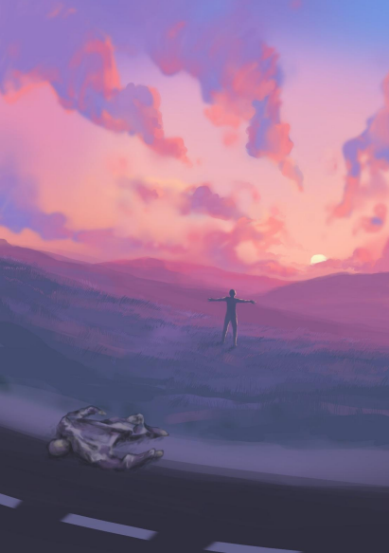
ID: This illustration looks like a sunrise scenery with beautiful clouds and hills. It has all the colors of the sky at dawn. At the bottom of the illustration, we can see a road. On that road what looks like the shed skin of a whole human being, including a head, is lying face down. It looks battered and lifeless. In the center of the illustration, just a few steps away from the battered body, we can see a person standing with arms open, facing the sun. We can see the light of the dawn reflecting on this person. We can also see a shadow behind the person. The sky is filled with clouds.
I Am
Sanchayita
Let me begin this with a quote:
“There is an idea of a Patrick Bateman.
Some kind of abstraction,
but there is no real me.
Only an entity — something illusory.
And though I can hide my cold gaze...
and you can shake my hand and feel flesh gripping yours…
and maybe you can even sense our lifestyles are probably comparable,
I simply am not there.”
This rather dramatic quote comes from American Psycho (2000). Patrick Bateman is a soulless murderer. While I don’t particularly relate to his character, this particular quote is perhaps the best description of myself till the age of 23.
I grew up as a deeply alienated person, with no sense of “self”. I was not allowed to develop one. My parents, my teachers, and sometimes my peers tried to create their idea of what I should be like. I did not fit their molds, or their ideals. I was not interested in maths. Or science. Or the latest shows on MTV. Or painting.

