TITLE: If Our Healing Is Unlocatable, Where Do We Pin Our Destination?
STRAP LINE: When some individuals take both their caste and queerness to therapy in the hope of finding healing, they often return empty-handed. Why?

Text by Sudipta Das

The Delhi house that I live in has a pond at the edge of our extended courtyard. My friends, parents, colleagues and I often sit there, touching each other’s hands and souls, far, far away from the injuries of the outside world. Touching the tip of the water with our toes, sharing poems and phrases, we bask in joy, thinking of this community.
From afar, the mallards look at us in awe. The trees sway gently as the sun casts a soft shadow upon us and the fish in the pond slowly circle our feet. We adorn our wavy, flowing hair with amaltas flowers and peer into the water, looking at our reflections, mesmerised. We think to ourselves, “How pretty and loved we all are!”

It’s all a lie. Realities like these don’t exist. Not for us.
It’s a daydream I carry. Like many of you do too.
To escape collapsing mental health.
We don’t want to, yet we also carry memories in this body that aren’t as pleasing as our fantasies.
We carry the undeniable truths of our rejections. We carry history that’s scripted on our skins and our bodies.
Our body has become a site of many politics. It comes with episodic epiphanies of how our desire relates to our desirability, our aspirations to our employability, our living to our loving—everything supposedly predestined.
My body embodies all that makes me a Dalit, queer, non-binary person. It is not ‘normal’ anymore. I am not ‘normal’.
Like many of you, the binary of ‘normal’ and ‘political’ throws me off too.
Being a cisgender man is normal; every other gender is political. Being ‘savarna’ is normal; everything else is political. Being heterosexual is normal; every other sexuality is political.
Indian-origin American psychoanalyst Dr Salman Akhtar, in his lecture ‘The Mental Pain of Minorities’, once said that a person from a minority community is either stared at or not seen at all; their presence is not ‘normal’.
What does ‘normal’ feel like? Is it the absence of the crawling fear in your stomach when someone stares at you longer than usual in the streets? Or the solace of coming back to socially sanctioned families at the end of a tiring day? Or carrying the pleasure of knowing that you are loved—just for your being, and not so much for your doings?
I am not sure if I desire normalcy. But I deeply, deeply envy everything ‘normal people’ have easy access to. Like effective mental health interventions designed with them and their needs at the centre of the process.
​​Thinking of notions of mental pain, normalcy, the historical criminalisation of neurodivergent people and how ‘Abolition Must Include Psychiatry’ in the US context, Stella Akua Mensah, a Black, neurodivergent peer support specialist, psych survivor, writer, transformative justice advocate and artist, says, “Psychiatry was built with a core desire to dehumanize, drug, and discard those whose behavior and ways of being diverged from the status quo. This status quo was and is white, patriarchal, and absolutely enamored with respectability and compliance with the state’s self-serving notions of ‘normalcy.’”
The expression of this status quo is different in our context in India, but the essence of who and what is ‘normal’ and who and what isn’t is again defined and defied through generations.
The house that I actually live in, in Malviya Nagar in Delhi, is pretty cosy. It faces a not-so-green park, a grocery shop and densely packed buildings—one atop another, without a beginning, without an ending.
***

After seven years of a working life, I finally decided to invest in air conditioning last summer. Living in Delhi for quite some time now has taught me that I certainly can’t cry my way through the scorching, humid summers. But this is the first time ever in my life that I will have air conditioning in my room—a room that I have rented with my own money, holding the life that I have curated for myself, far away from the predictions of what my life would be, should be.
While installing this window AC, a glass pane was removed from the window. A friend and I drew on it a magical, mystical, womanly figure staring coldly into the distance. A feline, starry-bodied creature wrapped around their neck. A half-moon hung out, emerging from their body.
I lost that friendship. Nobody had warned me that friends can break your heart too.
Months later, one morning, the glass painting shattered on my leg, leaving me bleeding on the floor. That was my loneliest night. The scariest. What if things kept breaking and fading away, leaving only scars?
For queers like me—emotionally emancipated from our natal families, in a complicated relationship with our neurodivergence, with our dismayed country denying us legal rights to any version of coupledom, with limited access to queer relationships because of our castes— disappearing friendships can mean the end of our world.

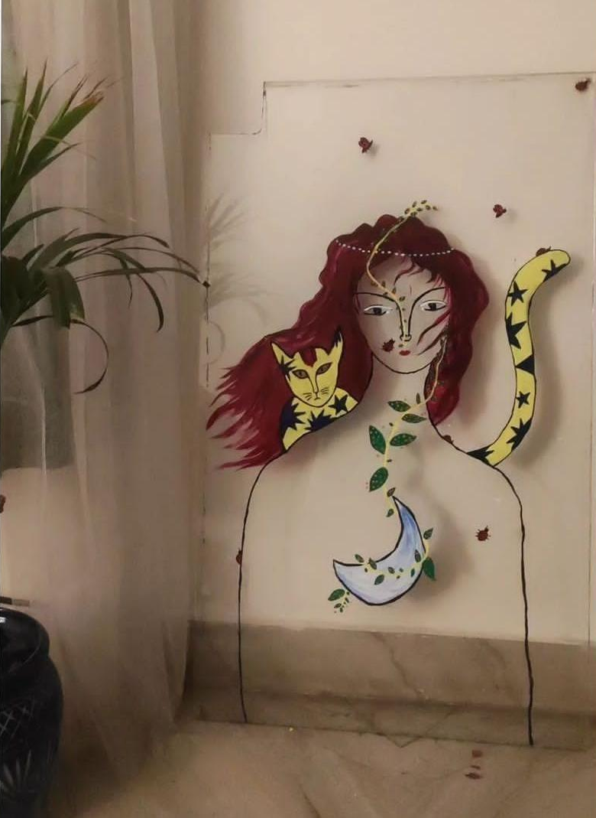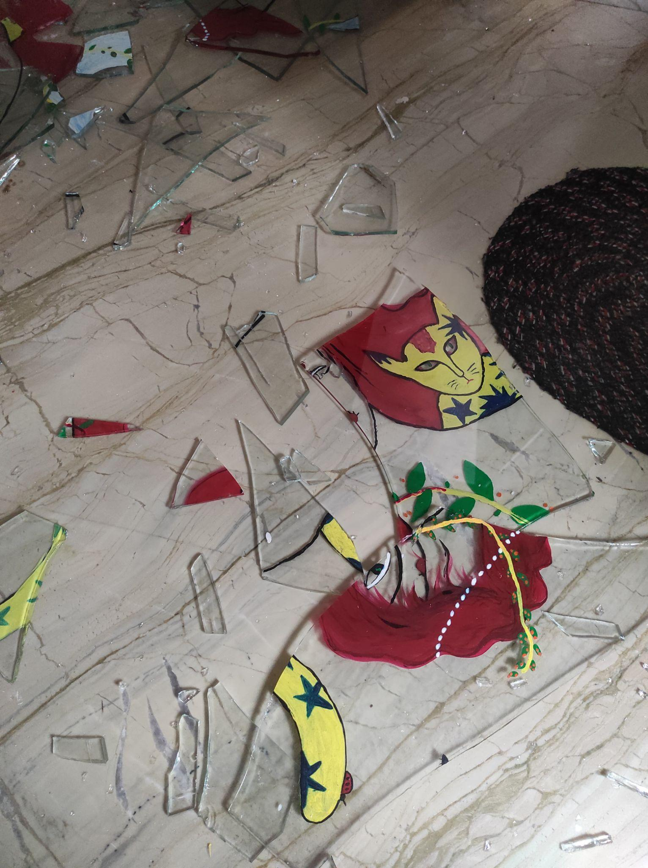

Seeking a place with no pain
In times like these, the only thing I hold on to is the house by the pond in my imagination. The house is in ‘Begumpura’ – the ‘place with no pain’. Centuries ago, Sant Ravidas nurtured a sacred longing in his heart to establish a society where discrimination based on caste, gender, social and economic status did not exist—a place free from suffering. He was the pioneer who envisioned an Indian utopia in his song ‘Begumpura’, contrasting the dystopian reality of the brahmanical Kaliyuga he found himself occupying. I find myself immersed in the verses of the shabad, reading and re-reading Ravidas’s dream of a city void of sorrow and discrimination.

Begumpura
Sant Ravidas

The regal real with the sorrowless name:
They call it Begumpura, a place with no pain,
No taxes or cares, nor own property there,
No wrongdoing, worry, terror or torture.
Oh, my brother, I’ve come to take it as my own,
My distant home, where everything is right.
That imperial kingdom is rich and secure,
Where none are third or second—all are one;
Its food and drink are famous, and those who live there,
Dwell in satisfaction and in wealth.
They do this or that; they walk where they wish,
They stroll through fabled places unchallenged.
Oh, says Ravidas, a tanner now set free,
Those who walk beside me are my friends.
(Hawley and Juergensmeyer, 32.)

Why is it that even when I exert all my strength, hope and will to manifest in my pursuit of Begumpura, it fades further away the closer I come? How do I reach my healing? My therapist says all the right things to make sense of queer friendships. They speak of the anticipation of loneliness of mind and ageing of the body—except they don’t really utter words that are ‘too political’. It is much like what Rachelle Bharathi Chandran wrote in ‘Navigating healthcare as a Dalit, non-binary person with debilitating social anxiety’: “How can I as a Dalit person ever feel comfortable talking about caste to a therapist who repeats every word except ‘caste’?”
In academia, therapists are not trained to handle caste; it is not part of their syllabus. Recent research into undergraduate courses at Delhi University expose the nakedness of the systems that perpetuate casteism in therapy practices by erasing caste from the curriculums. On the other hand, though ‘conversion therapy’ was categorised as professional misconduct in September 2022 by the National Medical Commission (NMC), it is still widely practised by some therapists.
A lot has indeed changed in the past decade. Significant shifts can be located in mental health approaches, with the introduction of queer-affirmative therapy, though it’s still not widely accessible. Yet, in the face of the terror that is our crumbling mental health, some of us from smaller cities have now experienced social mobility through university education, through migration to bigger cities, through exposure to resources that both capture and rupture our realities—and we often find ourselves clueless about how much of our pain can be comprehended by a therapist, how much can be brought into therapy.
As I write of this pain and read Gail Omvedt’s Seeking Begumpura, I think and rethink how much of our suffering and our experiences of the struggle to access healing I want to put on display. Our marginalisations have taught us: everything we say is ‘too political’. Everything that we say can be used against us.
What is it in our existence that makes us want to shrink more and more? What makes us labour to occupy less space, we with our complex, intersecting identities? Is it the fear of how our bodies have become sites of suffering? Or is it how we lose the plot of our own stories, our lives reduced to only narratives of resistance? Or is it how the systems that scaffold us are equally perplexed about where our healing and pain overlaps?

Community Healing: Who does it belong to, who belongs to it?
In many cultures, healing is a community event with room for connection, the telling of stories, and support, a vast difference to the Western ‘individualistic’ approach to healing, largely an isolated, private affair. In India, colonisation’s long shadow makes for an uneasy, unnatural hodgepodge of the two approaches.
However, many therapists and mental health professionals also advocate for decolonising mental health in India, applying an Eastern understanding of mental health—that suffering is in the nature of the universe and that collective suffering requires collective compassion.
Decolonising mental health also presents the opportunity to build conversations around non-metropolitan, ethnic queer subcultures that are rooted in our colloquial past(s) and present. This discourse offers much richness and complexity while reimagining queer mental health beyond clinics. Growing up in the suburbs of Kolkata, with the limited vocabulary of queerness that we had, I found home in the vernacular term kothi, which isn’t part of the mainstream comprehension of queerness for most of the country. It was kothis who extended comfort and solidarity to help us comprehend who we are and all that we could be.
Before the popularisation of the term kothi in Bengal, transfeminine persons often referred to themselves as dhurani. Scholar Aniruddha Dutta writes in a Bengali magazine fondly of their interaction with the late Bappa-da, an important figure in queer-trans organising in Bengal. They reminisce in Bengali (and I translate): “We had so much fun at our Janbazar residence... There weren’t many NGOs at the time, or at least we didn't know of many. My house became the hangout. So many dhuranis would come from Kakinara, Singur! Our house was conveniently near Sealdah (railway station), so many people could come. I have cooked for so many dhuranis! And then in the evening, I would get all decked up, performing mujra. So many dhuranis used to come, even boys!”
Aniruddha also writes about many such informal networks anchored and nurtured by queer-trans elders like Bappa-da, who held space for many kothi-dhurani-hijra people from small towns, suburbs and cities. Today, in cities, much of queer-trans organising is centred around NGO-sponsored, corporate-funded events, festivals and parties. This tends to often reinforce the problematic idea of social locations as determinants of participation and access.
While writing about community healing, founder of Blue Dawn (a support group and facilitator of accessible mental healthcare services for Bahujan communities) Divya Kandukuri writes, “My mother sits with the neighbourhood women for an hour every evening. In that time (and this has been going on for years), they talk about the problems they are facing, from domestic issues, gendered violence, to caste discrimination. They have even developed an informal money lending system to support each other financially like we have seen women’s collectives and self-help groups across India do.”
While there is so much hope in community – and often as marginalised folks we are told in therapy that communities are our source of healing – I feel a little lost sometimes. Talking with my friend Zayan has helped me make meaning around community healing, what it looks like for him and for many of us, as we stand at the crossroads.
Thinking of his own experiences of accessing communities, he said, “The first time I had access to community was when I got into the master’s programme at Ambedkar University and became part of the queer collective there. It was a breath of fresh air. I had no access to such queer groups during my graduation days, but I really wanted to get into AUD because of the fee waiver for Dalit students and a pre-existing queer collective. As I began working in a queer rights organisation, my access to queer friendships grew, with the reassurance that there were people to fall back on.”
We were speaking on a Zoom call with shaky internet and rocky emotions. Still, I could discern a slight shadow on Zayan's face as he paused to sigh.
He continued, “Sometimes I too feel alienated in this community. Once, in a bougie place, I attended a queer event where everyone around me spoke a certain language and appeared a certain way [upper class]. I felt I should leave. I felt I could never be part of these spaces completely. I thought to myself, ‘Am I appropriately dressed?’ Sometimes I wonder: do other people think of clothes as much as we do as markers of where we come from and not only as fashion? Sometimes we just end up performing our queerness based on our learnings from savarna queers as we try to become ‘queer enough’, ‘trans enough’.”
Zayan has been working in the field of queer rights, organising and mobilising for years now. He is assertive of his trans-masc, Dalit identity. During a queer event held in Delhi during the chilly December of 2023, he had an intriguing encounter with a certain individual. In a casual conversation, the person remarked that they found it amusing to see several Dalit individuals speaking on the panel. Zayan openly disclosed that he, too, was of the Dalit community. This revelation was received with an awkward silence, followed by the person quietly murmuring that they hadn’t perceived Zayan as Dalit.
A homogeneous imagination and expectation of our realities disqualifies many of us from the simple joy of being many things — especially being flawed. Though it may appear harmless on the face of it, deep down, it constructs a feeling of being ‘not enough’ within us — a heart-breaking tactic to deny us communities. But if we all feel ‘not enough’, what does feeling ‘enough’ look like?
I’ve never understood people who trust in who they are, without questioning themselves endlessly. Isn’t that the human thing to do? Bemused and curious, I reached out to Shoi. They are a transmasc nonbinary Dalit person who loves illustrating and currently works with an organisation in Kolkata. Last year, both of us ventured into making a docuseries about queer people’s experiences and reflections on ‘love’ while residing on the margins of the systems of caste and religion.
During their master’s degree in Dalit and tribal studies, Shoi was part of Dalit circles in in their university in Mumbai. They often feel that, given Maharashtra’s Dalit politics, in some spaces the extent of one’s Dalitness is also determined by geolocation of natality. Born and brought up in West Bengal, Shoi relocated to Mumbai for their education. As a native Bengali speaker, communicating in Hindi has been difficult for them; so they have directed more efforts into sharpening their English, which also promises better access to opportunities and greater overall mobility. Once, while they were speaking in English in the classroom, some of their classmates came to Shoi after the class to commend their fluency. One man in the group said, “You are toh an emancipated Dalit.”
Revisiting this memory, Shoi feels many things. While on the one hand despising the larger politics of linguistic imperialism that upholds Hindi as the supreme language of this ‘Hindu rashtra’ and the naïve vision that can only imagine this nation as an extension of ‘North India’ into all corners of this country, they add: “I question my understanding of my caste. ‘Dalits’ are often seen as a homogeneous community. If you don’t fit into that, who do you belong to?”
One of Shoi’s friends confided how she deliberates every time before wearing expensive accessories or clothing that may disrupt her image as a ‘Dalit person’. At the university, alongside the struggle to conform to the ‘Dalit image’ includes the challenge of feeling ‘Dalit enough’.
I ask myself: What is community for me? Larger communities that are shaped by all my identities – the language I speak, the religion I was born into, my citizenship? Family, of blood or choice? Friends, lovers and everybody in between? My flatmates? I am not sure!
One of my flatmates once told me a story about his university days. He illustrated a wall in his hostel room with amorphous figures, drawn in colours and shapes that the lazy might read as ‘eerie’. But his mural possessed much deeper meanings that not many people outside the room could truly grasp. On the inside of the door to his room, he had painted the word ‘entry’ in bold red and on the outside ‘exit’. From his perspective, he was entering and exiting the outside world when he left his room or returned to it. In the muddled overlaps where many communities and senses of safety meet, materialise often amorphous rooms with bewildering meanings of what ‘entry’ and ‘exit’ means for each of us.
One can’t deny with certainty that there is a lack of dedicated spaces that allow us to articulate and pursue our experiences as caste-marginalised queer people — spaces that not only allow us to discuss mental health, well-being or neurodivergence, but also our everyday joys and the mundane experiences of living in this country. Friendships with other people who come from the same experiences have been life-saving for many of us, yet the perplexing absence of larger Dalit-queer spaces remains a conundrum.
The rupture of and departure from communities means loneliness. In therapy, understanding the loneliness experienced by individuals who belong to multiple communities, and therefore may only have fragmented access to each, allows us to situate ourselves in our entirety. In my experience and the experiences of friends that I spoke to for this piece, we realised when we are told in therapy to seek community to counter crawling loneliness, the inability to access communities isn’t a personal failure but more of a systemic roadblock. In the end, decolonising mental health requires more than just dismantling white supremacy and easy understanding of community access in our ‘one nation’; it necessitates an understanding of how caste, religion, language and more influence the shaping and gatekeeping of communities.

The (a)Politicality of Therapists
Jaat-paat ke pher mah urjhai rahe sabh log/ Mannukhta ku khat hai Ravidas jat ka rog (Everyone is trapped in the caste system/ Ravidas, humanity is being eaten up by the disease called caste)

For the longest time, we had been taught that all mental health ‘diseases’ and problems are rooted in people’s bodies and identities—until there was the realisation of flawed medicalisation of people on the margins. People’s bodies and identities aren’t the sites where these problems originate or reside; oppressive structures are.
It is important to remember that until the 1970s, the American Psychiatric Association’s Diagnostic and Statistical Manual of Mental Disorders (DSM) classified homosexuality as a mental illness. This reflects a worldview, which the DSM continues to be rooted in, that tends to focus on identifying individual pathologies rather than recognising the systemic issues that contribute to the societal challenges that generate them and follow from them. Jackie Menjivar, the Manager of Peer and Youth Advocacy at Mental Health America, highlights that some argue that the pathologisation of behaviours outside of the dominant culture is not merely an unintended consequence of the biomedical model of mental health, but rather a deliberate outcome of the system.
An individual’s social identities operate simultaneously to either enhance or constrain their life experiences at individual, interpersonal and institutional levels. A lot of research discusses identity-related inequalities in mental health experiences and intervention outcomes in terms of individuals’ gender, caste, religion, sexuality, etc. Minorities and stigmatised groups are disproportionately affected by certain stressors and the prevalence of mental disorders such as depression and anxiety is higher among them as compared to the general population. The failure to recognise these factors and their fallouts in therapy rooms often affects our relationship with therapy and can also perpetuate systemic harm and inequality.
The first time Shoi went to therapy, they were only 14.
“My grandparents are from Bangladesh. During Partition, they had to migrate to India. My mother grew up witnessing communal violence and separations through most of her childhood years. I was born in Nadia, where many Bangladeshi refugees from caste-marginalised Hindu groups lived. Then we moved to the city, to Kolkata, when I was 10,” they said.
Adjusting to the faux-casteless mindset of the city was bewildering for Shoi on many fronts. At their new school, they were soon singled out for their food choices. There are certain foods that are looked on with suspicion and often met with disgust, but in some communities it is quite normal to eat certain animals, small birds, pork and quail eggs.
The portal Homegrown reported that while some indicators of caste — such as dirt, ‘pollution’, water segregation and the division of wells — are widely recognised in India, the structuring of food hierarchies that singles out Dalit communities remains a relatively obscure topic, despite its clear consequences.
Once, Shoi’s mother packed boiled quail eggs in their school lunchbox. It was shortly before the school’s annual function and several students were rehearsing together in the hall for their dance performance. All of them sat down together to have lunch. When Shoi opened their tiffin box, they were treated with disapproving stares.
“I do carry blurry memories of being called many names post that day. One of them that almost felt like an inseparable companion throughout my school days was being called ‘gaiya’ [illiterate or uncivilised, because non-urban],” recalls Shoi.

The article ‘Dalit Identity and Food—Memories of Trauma on a Plate’ underscores how caste made Dalit people eat what they eat—but it’s the social narratives built around their diets that determine the everyday stigma of Dalit food practices. “Upper castes make it sound like we are dirty and that we eat things that are dirty. If I eat pig meat, I am marked a ‘pig-eater’. If an upper-caste person eats it, it becomes ‘pork’, the rich man’s delicacy,” says Deepa Tak.
In 2014, when Shoi was 14, they were jolted by repeated panic attacks, followed by a sinking, spiralling into a void. These experiences became chronic, extending and expanding. People around them couldn’t comprehend what was happening to them, within them.
Shoi continued to be consumed by the paralysing void for months, impacting their mobility, dictating their absence from schools for weeks, shutting down all social interaction, feeling cut off from anything that could make them feel themself. And so they continued, until finally a debilitating panic attack in school—where they completely froze, gasping, helpless and collapsed—saw them taken to a hospital.
Two months in and out of hospitals, visiting psychiatrists, countless medications, before they were eventually diagnosed with clinical depression and anxiety. And so their therapy began.
This was also the time they began to have feelings for a girl at school. Shoi remembers, “I felt attracted towards her. Being a young queer person, there are not many spaces you can speak of your desires—spaces to not only express your feelings but to also make sense of who you are. She was my safe space. She was my home. She was the person in whom I confided, the space where I felt cared for.”
People who have lived our kind of life know that the arrival of anything that nurtures our queerness is only seen as a threat, while sameness is perpetuated as the only version of safety. So the first thing our parents do is uproot us from our authenticity to resist our falling out from the ‘sameness’. Shoi’s parents cut them off from the girl at school, took away their phone and sighed in relief, assuming they now knew the source and had traced the root of Shoi’s collapsing mental health — their queerness.
“I discussed this with my therapist at the time. He was a cis-man, middle-aged. His inappropriate line of questioning — has anybody ever touched my breasts or other parts, how I feel when I touch myself — made me feel extremely vulnerable. By this time, as my vulnerability was out in the open for other people to access, my agency to decide anything for myself seemed trivial. He tried convincing me that I am too young to really know if I am attracted to a girl or not. He explained how when a boy would touch me, I would actually feel nicer,” said Shoi.
These early violent experiences of therapy contributed to Shoi’s complicated relationship with therapy, to a large extent. They seek therapy when they have to. When their psychiatrist asks them to go to therapy, they might consider going; but even then, they must keep reminding themself that it may be two sessions or some weeks that they must force themself there, and then they can stop. The moment the medicines start kicking in and they approach stability, they stop going to therapy immediately.
At the university in Mumbai where Shoi completed their master’s this year in 2024, there are provisions for therapy services mandated by the university council. The providers are supposed to be queer-affirmative and anti-caste practitioners. Except, they aren’t.
During placement season, when Shoi talked about their distress and anticipation of not being shortlisted for jobs in top NGOs, corporate companies, for-profits, the therapist breezily assured them that things would get better. With the plethora of thoughts brewing up a storm inside Shoi’s mind, they hesitantly shared: “Why is it only… mostly… students with upper-caste surnames who get shortlisted for most of these job openings? Are only they deserving? Am I overthinking, or am I actually not good enough?”
Without any pause or much hesitancy — unlike Shoi — the therapist knew what she had to say (and it is something that some of us get to hear in our therapy sessions repeatedly, across different contexts): “Who looks at your caste here? You are just like everyone else here?” This was enough for Shoi to shut down. Again.
Mental health professionals (MHPs) coming from an oppressor caste are often unable to dismantle their own caste privilege, and are unwilling to look at casteism as a significant contributor to mental distress in an individual. When we speak of caste, we only think of it as oppression and not as a privilege, which shifts the burden of holding knowledge of these systems (and attempting their dismantling) on to the people harmed by those very systems — and away from the people still benefiting from these same systems even as they refuse to take responsibility for how they perpetuate the harm.
Thinking more about this, Shoi reflected, “Privileged people experience things without linking it to caste, sexuality, neuroconformity, unlike us. They feel good things happen to them because they are good people. Not because they have access to resources, social privilege or generational wealth. They think they are successful or meritorious because they work hard! I might work twice as hard but still not be where they are and historically have been.”
In their writing on how ‘Access Intimacy in Therapy Shelters Queer Disabled Hope’, Anna Maria, a queer and disabled psychologist and writer, delves into the messiness of the blazing question of ‘Should therapists speak about their lives?’
I pose the same question to myself, to Zayan, to Shoi, to friends and lovers, only to realise that for many of us with ‘political’ identities, it has become instinctive for us while seeking a therapist to first attempt an understanding of their political stance — not just in terms of their personal identities but also their broader views on citizenship and rights.
As users, we seek comfort in knowing a therapist’s politics, which is often conveyed through their approach to healing, the practices they uphold, their expressions of solidarity — and not necessarily talking about their own lives and lived experiences. As users, we are evolving in our approach to accessing healing, which might not be the same for therapists as disclosing their identities to their clients in therapy goes against what therapist training teaches them. However, sometimes disclosing stigmatised identities is also risky, as clients may sometimes be outright queer-negative or casteist. Additionally, the competency of a service provider is often deeply tied to their social locations, making it difficult for Dalit therapists to assert their identity, as Dalit people’s competency and merit are continually questioned.
Still, one cannot overlook the glaring lack of Dalit therapists anyway. Paras, co-founder of The Alternative Story, an organisation providing caste-aware and intersectional therapy, emphasises, “No amount of anti-caste discourse being read and consumed by a savarna mental health professional will replace a trained and qualified DBA (Dalit, Bahujan, Adivasi) mental health professional. The actual change will come when we focus on increasing the number of DBA students in postgraduate psychology programmes and incentivise this profession for them.”
Until that happens, some training and courses on queer-affirmative therapy and anti-caste mental health practices for all therapists offered by some civil society organisations. Unfortunately, though, this isn’t an extensive part of the pedagogy of Indian psychiatry. It thus becomes a ‘specialisation’ rather than a universal default practice, which automatically makes such services exclusive. Justice-oriented counsellor Ji-Youn Kim writes on her blog: “Unless therapists are proactively educating themselves on anti-oppression and unpacking their own complicity as individuals, therapists will have an incomplete understanding of trauma and therapeutic practice when supporting clients who experience any form of systemic oppression.”
Therapy is political, and while very few of us can afford therapy in the country, even fewer can afford to unsee the apoliticality often present in therapy rooms.

How do we say what hasn't been said before?
When I wrote to my friend Eshana (name changed), a bisexual Dalit woman who is currently principal of a school in Pune, about this essay, she told me of her recent experiences with accessing therapy.
Eshana is bold, brave and sensitive, and I remember telling her once how easy it is to love her.
Is it the invisible pain we carry that makes us feel we belong, or the untold secret that we see each other’s pain and healing? These are ours, but they don't belong to us alone; we aren’t sure. Or is it the cold hands from our ghostly pasts, the trauma that is shared and intergenerational?
Sometimes we fail to explain that as people from marginalised communities, our well-being isn’t only about our own individual experiences but also the way members of our entire community are treated. When our friends tell us of something terrible that has happened to them, if our mind draws a parallel, recognises it for something that is a possible experience lying in wait for ourself also as a queer person or a Dalit person (or both!), then our body curls up in anguish and fear for both of us. When we read about atrocities against our people, even those far, far away from where us geographically yet closest to our own experiences, how can we see that event as one occurring ‘at a distance’, and not as a present threat to our own tomorrow?
We might not talk of these things often, but the fear is often shared within our Dalit families. When we are bullied for availing reservations or singled out for our food choices, or insulted for coming from ‘working class’ families, we hold each other in grief and care in our natal families. But we can’t look past another grief of knowing that for many queer-trans people, our families are often the primary sites of violence. ‘Home’ becomes a paradoxical space that is both sanctuary and battlefield, where many truths and lies crawl all over each other, trying to put up a show of sanity — and constantly fail.
For Eshana, whose Dalit mother married into an upper-caste family, seeing how her mother is treated in the marriage, how her mother’s side of the family is always submissive, makes her angry. The memories of childhood sexual abuse by her paternal uncle and the silence around it was again a reminder of power dynamics in some inter-caste marriages. These exist in the many folds of the fabric she wove in making sense of her world.
“When I take all this anger to my therapist, they often comprehend it in a binary model, belying the complexity of my feelings. The therapist often tells me how my anger might be related to needs that weren’t met in my childhood. There is a lot of emphasis on going back to childhood experiences and looking at my unmet needs from my primary caregivers (they meant parents). But there were so many of my needs that were denied through institutions and social circles.”
While many of us may have a complex relationship with our parents or natal families, it’s important to recognise that attributing all our hurt and trauma solely to them dismisses how some of us might also share deep resonance with them in terms of our caste experiences. We have grown up seeing our families treated differently, helpless when denied respectability, walking on eggshells. Evolving psychiatric and healing practices within mental health frameworks require reflection upon these complex experiences, including how childhood experiences are also complex in their interaction with multiple social systems. Therapists must take into account not only the trauma derived from natal families but denial of care through these other social systems, such as schools, friendships, neighbourhood communities.
This also means recognising the role of intergenerational or historic trauma, in addition to individual trauma. Understanding how ancestral trauma, such as untouchability or forcing people into menial work, continues to manifest in our present-day oppression and inequality is essential. Healing from individual suffering cannot fully occur without addressing these broader collective contexts.
Meaning making is collective work. Most of our learning about queer negativity, casteism and exclusion has been shaped by the articulations of Dalit, queer-trans, marginalised people. They put enormous labour into citing their lived experiences and disclosing their knowledge to educate people — most importantly, the ones continuing to benefit from their oppression, or even actively perpetuating it or denying its very existence (another new trauma, mass if not historic).
Yet, in spaces where we experience deep, strange, unknown discomfort, sometimes we don’t have access to the vocabulary or articulation to explain why we feel the way we feel. Our expressions crumble as we struggle to emote anything beyond repulsion or indifference. Meanwhile, the people outside of our immersive experience of marginalisation often seem not to care about our feelings. For them, saying and doing ‘the right thing’, as informed solely by the preexisting articulations, seems sufficient.
What we may not realise is that a lot has not been articulated yet. And that is why engaging the affected users while conceptualising therapeutic interventions is important and should be ongoing work. There can be no arrival at a state of ‘knowing it all’.
During her university days in 2015, Eshana was denied a key position despite her qualifications and experience as the assistant magazine secretary. A savarna person got the position. The recurring pattern of savarnas holding positions of power fuelled her anger and envy, leaving her endlessly questioning herself as to whether she was seeing casteism because of her prior life experiences, her community’s history — or whether it was actually in operation in this case. The mere existence of this thought, with no tangible evidence to call out the appointment as caste prejudice and no one to articulate it made her feel as though she was holding an enormous shapeless truth in her throat. In that loss of vocabulary and meaning, she reached for her therapist to steady herself — only to find disappointment.
“When I take all of these [thoughts and feelings] to my therapist and struggle with making sense of my thoughts, she sometimes is clueless about directing me anywhere.” said Eshana.

In-betweens and Beyond
The space between knowing and unknowing is where many of us reside. We use language, therapy, community and many other things to desperately locate ourselves and our healing.
Therapy has supported us through the disjointed injuries inflicted by the outside world. However, while there are a few therapists from marginalized communities tirelessly working to create a better mental health service ecosystem, mainstream therapy spaces are still far from catching up. The possibility of an affirming therapy environment brings us waves of euphoria and that is the only truth we want to hold on to. We trust that therapists, mental health professionals, peer counsellors, advocates of mental health and well-being — all of us — share the same vision. That is why, even as you create and curate anti-caste knowledge and queer-affirmative therapy practices, we are here giving our first-hand knowledge, our experience of social structures and of the impact of your power in the therapy room. As therapy users and not mental health experts, yet certainly experts on our own lives, we wish to convey what accessing healing truly means to us. This is not only a critique but a compassionate offering of the hope that perhaps Begumpura — a place without pain — isn’t only an illusion, but a possibility for all of us.
The good news is that therapy isn’t the sole means of accessing healing. The good news is also that therapy is a means of accessing healing.

Kothis are a heterogeneous group, typically referring to effeminate AMAB (assigned male at birth) individuals. It is unrealistic to expect that a single 'definition' of Kothi identity will fit everyone who identifies with it. The meanings attached to Kothi identity vary according to region, language, age group, socioeconomic status, educational status, and from one Kothi-identified person to another.
While caste works patrilineally, a person’s conception of themselves is different.
Madhopuri, B. (2018). Building Begumpura. The Indian Express. https://indianexpress.com/article/opinion/columns/guru-ravidas-poems-punjabi-begumpura-society-5975930/

