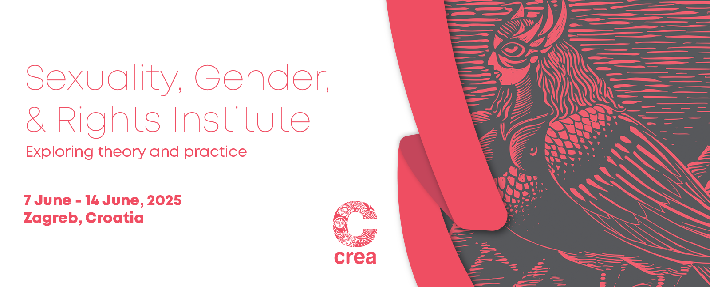

Call for Applications

Application Deadline: 10 February, 2025

The Institute

CREA’s Sexuality, Gender and Rights Institute (SGRI) is a residential course, started in 2007, which focuses on a conceptual study of sexuality. It examines the links between sexuality, gender, and rights, and their interface with socio-cultural and legal issues. The Institute is not a training or workshop. It attempts to recast the idea of collective and experiential ways of learning, emphasizing ‘classroom-based’ learning led by world-class faculty.

Timings
9 am to 7 pm (on some days, past 7 pm)

Venue
Le Premier Hotel

Institute Content
Sexuality is a complex field of study, which spans multiple disciplines and areas of work. Accordingly, the course content of the SGRI will focus on a conceptual and theoretical study of sexuality, drawing from different social science disciplines and the intersections between them.
Themes:
- Social construction theories of sexuality
- Sexuality, human rights, and criminal law
- Sexuality, gender, and power
- Sexuality, freedom of expression, and censorship
- Sexuality, media, and culture
- Sexual and gender diversities, and diversity of sex characteristics and rights
- Sexuality and disability
- Anti-gender mobilization and human rights claims
- Case studies of program interventions

Institute Pedagogy
Activists, practitioners and academics will teach the course using classroom instruction, group work, case studies, simulation exercises, fiction and film.
- The Institute emphasizes linking theory to practice
- Participants will learn to critically analyze policy and research their own program interventions using a rights-based approach
- The Institute is not a training or workshop, and attempts to recast the idea of collective and experiential ways of learning
- The Institute emphasizes learning led by world-class faculty

Faculty
Faculty will include, in alphabetical order:
Alice Miller, JD, an Associate Professor (Adjunct) of Law at Yale Law School and Co-Director of the Global Health Justice Partnership. She is also an Assistant Clinical Professor at the Yale School of Public Health.
Carole Vance, PhD, MPH, an internationally recognized anthropologist who has published widely on sexuality, human rights, science, gender, and health. She coordinated the landmark Barnard Conference on Sexuality and edited the volume Pleasure and Danger: Exploring Female Sexuality.
Estefania Vela, Executive Director of Intersecta, a feminist research and advocacy organization committed to ending gender discrimination in Mexico through the promotion of intersectional and evidence-based policies. Vela holds an LLM from Yale Law School.
Geetanjali Misra, Co-Founder and Executive Director of CREA. Misra has worked at the activist, grant-making, and policy levels on issues of sexuality, reproductive health, gender, and rights. She has been an Adjunct Professor at the Columbia University Mailman School of Public Health.
Katrina Karkazis, PhD, a cultural anthropologist working at the intersection of science and technology studies, theories of gender and race, social studies of medicine, and bioethics, whose research and teaching examine—and challenge—scientific and medical beliefs about gender, sexuality and the body.
Meena Seshu, an activist for sex workers’ rights. She is the founder of the non-governmental organization SANGRAM (India), which is aimed at empowering sex workers.
Nidhi Ashok Goyal, is a disability rights and gender justice activist who has influenced global disability rights and gender policies, authored groundbreaking research and publications, and served in leadership and advisory roles across major women’s rights, human rights, multilateral and government projects and initiatives. She is the Founder and executive Director of a feminist disability rights organisation, Rising Flame.
Nishant Shah, a feminist, humanist, technologist and Professor/Programme Director of Global Media and Communication and Director of the Digital Narratives Studio at the Chinese University of Hong Kong.
Sealing Cheng, who received a PhD from the Institute of Social and Cultural
Anthropology, Oxford University, and became a Rockefeller postdoctoral fellow in Gender, Sexuality, Health, and Human Rights at the Columbia University Mailman School of Public Health. She teaches at the Chinese University of Hong Kong.
Sonia Corrêa (TBD), a researcher and advocate for gender equality, health, and sexuality. She currently co-chairs the global Sexuality Policy Watch program (SPW) at the Brazilian Interdisciplinary Association for AIDS in Rio de Janeiro, analyzing global trends in sexuality politics.
A special lecture by Shohini Ghosh, a renowned essayist on sexuality and popular culture, a documentary filmmaker, and the Sajjad Zaheer Professor of Media at the AJK Mass Communication Research Center, Jamia Millia Islamia University, New Delhi.

This is not an exhaustive list – faculty will include other reputable practitioners and scholars!

Application Criteria
The SGRI is for activists, service-providers, community organizers, researchers and human rights practitioners, working on issues of sexuality, sexual and gender diversity, and diversity of sex characteristics/LGBTIQ rights, sexual rights, sexual and reproductive health and rights, rights of persons with disabilities, HIV/AIDS, public health, violence against women/gender-based violence, health, and/or gender at the national, regional or global levels. A total of 30 participants will be selected to attend. Participants should be embedded in human rights and/or feminist movements or civil society, or be working closely with them. Full-time students are not eligible.
Note: We encourage individuals from the global South to apply. We invite members of structurally excluded groups to apply, regardless of location.

Application Deadline & Selection Process
Applications are due on or before the c.o.b 9 February, 2025. Applications will be evaluated and participants will be selected on a weekly basis so you are encouraged to apply as soon as possible. To apply online, find a link to the application form at the end. If you experience difficulty with the online form, please download, fill out and email the .doc version of the form to SGRIglobal2025@creaworld.org as soon as you can. Early applications are given priority. CREA staff will review each application carefully. We will only contact applicants who have been selected to attend.

Institute Cost
Registration fee:
- USD 250. All selected participants will have to pay this fee (including those receiving scholarships). This will have to be paid within one week after you receive your acceptance letter.
Course fees:
- USD 4000: participants working with donors/funders and international non-governmental organizations
- USD 2000: subsidized rate for participants who work with global South organizations
Course fees include: Tuition, a resource package, and accommodation (with breakfast) on a twin-sharing basis for the duration of the Institute (with check-in on 6 June and checkout on 15 June). Single room availability is very limited; participants who want single rooms should write to us at SGRIglobal2025@creaworld.org.
Course fees do not include:
- Travel costs to and from the Institute, including international airfare, visa expenses or local transport
- Daily lunches and dinners

Travel, Visa, and Travel Health Insurance
Participants are responsible for meeting all travel and visa costs, including travel to and from the Institute, and for obtaining a valid entry visa (if required) in time. CREA will support visa applications by providing the necessary documentation. Please check the visa requirements, as well as wait times to receive the visa, for your country to Croatia as soon as possible.
Dual- or multiple-entry Schengen visa-holders (for tourism) can enter, stay and transit in or through Croatia without an additional visa. See here for an overview of visa requirements.
Please note that every chosen participant (including scholarship recipients) will be required to pay for and obtain travel health insurance before they travel to the Institute, covering the entire duration of the Institute. Your travel health insurance plan should cover COVID-19 hospitalization/health services.
CREA will do its best to assist with visas but cannot guarantee their issuance.

Scholarships
A very small number of CREA scholarships are available on a need basis. Please note that the scholarship process is competitive. Apply early to be considered for a scholarship.
- Full Scholarship: CREA covers tuition, resource package, and accommodation on a twin-sharing basis
- Partial Scholarship: CREA covers USD 1250, you pay 750 to CREA
- Contribution Scholarship: CREA covers USD 750, you pay 1250 to CREA
Scholarships do not cover international travel, visa fees or local transport. Scholarship recipients will have to pay for their lunches and dinners. Scholarship recipients will also have to pay the registration fee.
Individuals eligible for scholarships:
- Those working for national/local organizations in the global South
- Those working and residing in the global South
- Those working with or in groups to advance the rights of structurally excluded people
Individuals not eligible for scholarships:
- Those working with international non-governmental organizations
- Those working at donor agencies/funding organizations

Funding Opportunities
We encourage participants to approach donors to ask them to sponsor their participation. Possible sources for funding include the organization you work for, your organization’s donors (some funders will consider travel grants to current grantees), the Astraea Lesbian Foundation for Justice, the African Women’s Development Fund (AWDF), the Ford Foundation, the Global Fund for Women, Women’s Fund Asia, Mama Cash, Open Society Foundation, Foundation for a Just Society, or any Women’s Funds in your region. We suggest that you begin researching options immediately upon submitting your application to us. CREA will also reach out to donors directly.

Accessibility and Language
We will provide reasonable accommodations for people with disabilities. The Institute will be conducted in English. English-language competency (including in reading) is strongly recommended for all applicants.
Contact: Write to SGRIglobal2025@creaworld.org if you have any questions, or if you have trouble with the online application form.

